Pregunta 1:**Incorrecto**

**Which of the following is used to control network traffic in AWS? (Choose two)**

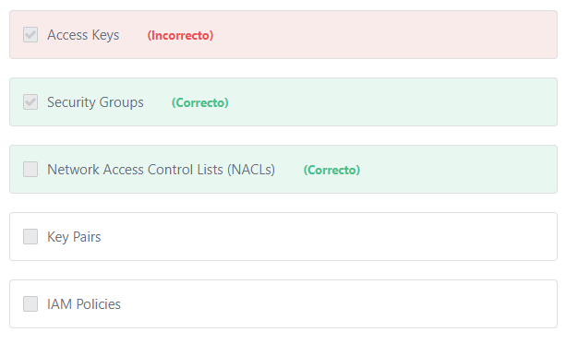

Principio del formulario

**Explicación**

             You can control network traffic in AWS by configuring security groups, network access control lists, and route tables.

1- Security groups: Act as a firewall for associated Amazon EC2 instances, controlling both inbound and outbound traffic at the instance level.

2- Network access control lists (ACLs): Act as a firewall for associated subnets, controlling both inbound and outbound traffic at the subnet level.

3- Route Tables: A route table contains a set of rules, called routes, that are used to determine where network traffic is directed.

**Note:**

**Controlling network traffic using any of the above methods is the responsibility of the customer.**

***The other options are incorrect:***

***"Access keys" is incorrect.***Access keys are long-term credentials for an IAM user or the AWS account root user. Access keys allows you to interact with AWS services programmatically using the AWS CLI or the AWS SDK.

***"IAM Policies" is incorrect.***By default, IAM users don't have permission to create or modify resources in AWS. IAM policies are used to grant IAM users permission to use the specific resources and API actions they'll need.

***"Key Pairs" is incorrect.***Amazon EC2 uses public-key cryptography to encrypt and decrypt login information. Public-key cryptography uses a public key to encrypt a piece of data, and then the recipient uses the private key to decrypt the data. The public and private keys are known as a key pair. Public-key cryptography enables you to securely access your instances using a private key instead of a password.

**References:**

<https://docs.aws.amazon.com/vpc/latest/userguide/VPC_Security.html>

<https://docs.aws.amazon.com/vpc/latest/userguide/VPC_Route_Tables.html>

Final del formulario

Principio del formulario

Pregunta 2:**Incorrecto**

**​ Which AWS Service can be used to register a new domain name?**

Final del formulario

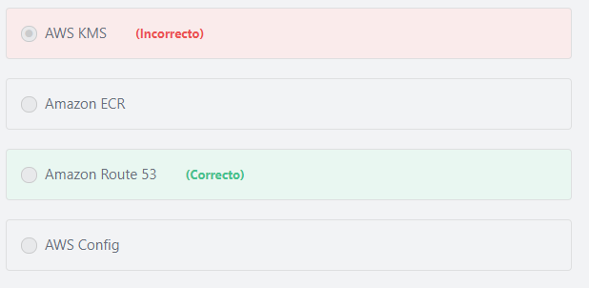

Principio del formulario

**Explicación**

            Route53 allows for registration of new domain names in AWS. Amazon Route 53 is a global service that provides a highly available and scalable Domain Name System (DNS) in the Cloud. It is designed to give developers and businesses an extremely reliable and cost effective way to route end users to Internet applications by translating names like www.example.com into the numeric IP addresses like 192.0.2.1 that computers use to connect to each other. Amazon Route 53 is fully compliant with IPv6 as well.

             Route 53 also simplifies the hybrid cloud by providing recursive DNS for your Amazon VPC and on-premises networks over AWS Direct Connect or AWS VPN.

***The other options are incorrect:***

***AWS KMS is incorrect.***AWS KMS is a managed service that enables you to easily encrypt your data. AWS KMS provides a highly available key storage, management, and auditing solution for you to encrypt data within your own applications and control the encryption of stored data across AWS services.

***Amazon ECR is incorrect.***Amazon Elastic Container Registry (ECR) is a Docker container registry.

***AWS Config is incorrect.*** AWS Config provides you with an AWS resource inventory, configuration history, and configuration change notifications to enable security and governance.

**References:**

<https://aws.amazon.com/route53/>

Final del formulario

Principio del formulario

Pregunta 3:**Correcto**

**Which statement best describes the concept of an AWS region?**

Final del formulario

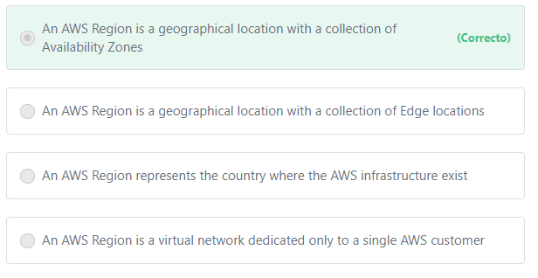

Principio del formulario

**Explicación**

              An AWS Region is a physical location in the world. Each region has multiple, isolated locations known as Availability Zones. Availability Zones consist of one or more discrete data centers, each with redundant power, networking, and connectivity. These Availability Zones offer you the ability to operate production applications and databases that are more highly available, fault tolerant, and scalable than would be possible to operate out of a single data center. Also, each AWS Region is designed to be completely isolated from the other AWS Regions. This achieves the greatest possible fault tolerance and stability.

**References:**

<https://docs.aws.amazon.com/AWSEC2/latest/UserGuide/using-regions-availability-zones.html>

Final del formulario

Principio del formulario

Pregunta 4:**Incorrecto**

**What are the benefits of using an AWS-managed service? (Choose two)**

Final del formulario

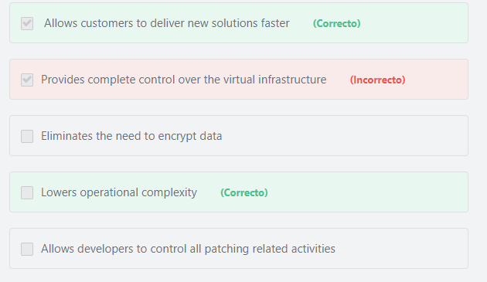

Principio del formulario

**Explicación**

              AWS services that are managed lower operational complexity by automating time-consuming administration tasks such as hardware provisioning, software setup, patching and backups. It frees you to focus on your applications so you can give them the fast performance, security and compatibility they need. Because these services are instantly available to developers, they reduce dependency on in-house specialized skills and allow organizations to deliver new solutions faster.

***The other options are incorrect:***

***"Provides complete control over the virtual infrastructure" is incorrect.*** When using a managed service you don’t have complete control of it. You are limited in what you can do with it. For example, Amazon RDS limits you to six database engines to choose from. However, Amazon EC2 allows you to install and run any database.

***"Allows developers to control all patching related activities" is incorrect.*** For managed services, patching activities are managed by AWS.

***"Eliminates the need to encrypt data" is incorrect.*** It is always the customer’s responsibility to encrypt data.

**References:**

<https://d1.awsstatic.com/whitepapers/aws-overview.pdf>

Final del formulario

Principio del formulario

Pregunta 5:**Incorrecto**

**What is the framework created by AWS Professional Services that helps organizations design a road map to successful cloud adoption?**

Final del formulario

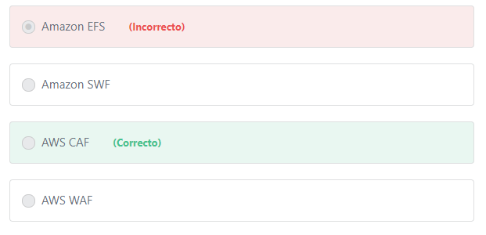

Principio del formulario

**Explicación**

             AWS Professional Services created the AWS Cloud Adoption Framework (AWS CAF) to help organizations design and travel an accelerated path to successful cloud adoption. The guidance and best practices provided by the framework help you build a comprehensive approach to cloud computing across your organization, and throughout your IT lifecycle. Using the AWS CAF helps you realize measurable business benefits from cloud adoption faster and with less risk.

***The other options are incorrect:***

***Amazon SWF is incorrect.*** Amazon Simple Workflow Service (SWF) is a web service that makes it easy to coordinate work across distributed application components. Amazon SWF enables applications for a range of use cases, including media processing, web application back-ends, business process workflows, and analytics pipelines, to be designed as a coordination of tasks.You can think of Amazon SWF as a fully-managed state tracker and task coordinator in the cloud. If your application’s steps take more than 500 milliseconds to complete, you need to track the state of processing. If you need to recover or retry if a task fails, Amazon SWF can help you.

***Amaozn EFS is incorrect.***Amazon Elastic File System (Amazon EFS) Amazon EFS is a fully-managed service that makes it easy to set up, scale, and cost-optimize file storage in the Amazon Cloud. Amazon EFS file systems can automatically scale from gigabytes to petabytes of data without needing to provision storage. Tens, hundreds, or even thousands of Amazon EC2 instances can access an Amazon EFS file system at the same time, and Amazon EFS provides consistent performance to each Amazon EC2 instance.

***AWS WAF is incorrect.***AWS WAF is a web application firewall that helps protect web applications from attacks by allowing you to configure rules that allow, block, or monitor (count) web requests based on conditions that you define.

**References:**

<https://aws.amazon.com/professional-services/CAF/>

Final del formulario

Principio del formulario

Pregunta 6:**Correcto**

**What is the most cost-effective purchasing option for running a set of EC2 instances that must always be available for a period of two months?**

Final del formulario

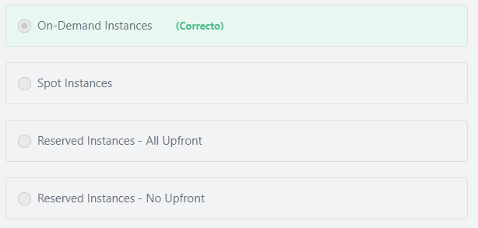

Principio del formulario

**Explicación**

The most cost-effective option for this scenario is to use On-Demand Instances.

***The other options are incorrect:***

***"Spot Instances" is incorrect.*** AWS Spot instances can be interrupted at any time by AWS. You should only choose Spot instances if the question clearly stated that the application can handle interruptions or if continuous processing is not required. Usually Spot instances are used for batch processing jobs or for non-production applications, such as development and test servers, where occasional downtime is acceptable.

***"Reserved Instances - All Upfront" and "Reserved Instances - No Upfront"are incorrect.***Since the duration is just for two months, we should use On-demand instances. Reserved instances require a purchase term of at least one year.

**References:**

<https://aws.amazon.com/ec2/pricing/on-demand/>

Final del formulario

Principio del formulario

Pregunta 7:**Incorrecto**

**A company has developed a media transcoding application in AWS. The application is designed to recover quickly from hardware failures. Which one of the following types of instance would be the most cost-effective choice to use?**

Final del formulario

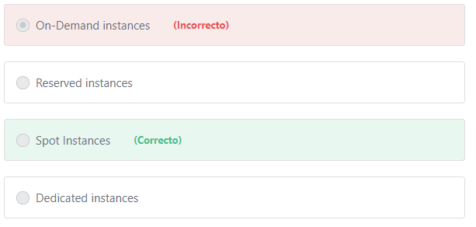

Principio del formulario

**Explicación**

           The question stated that the application is designed to recover quickly from failures, therefore it can handle any interruption may occur with the instance. Hence, we can use the Spot instances for this application. Spot instances provide a discount (up to 90%) off the On-Demand price.

         The Spot price is determined by long-term trends in supply and demand for EC2 spare capacity. If the Spot price exceeds the maximum price you specify for a given instance or if capacity is no longer available, your instance will automatically be interrupted.

          Spot Instances are the most cost-effective choice if you are flexible about when your applications run and if your applications can be interrupted. For example, Spot Instances are well-suited for data analysis, batch jobs, background processing, and optional tasks.

***The other options are incorrect:***

***"On-Demand instances" is incorrect.*** On-demand is not a cost-effective choice.

***"Reserved instances" is incorrect.***Reserved Instances provide a discount (up to 75%) compared to On-Demand instance. Even if the question stated that the company needs the instances for a year, the best answer should still be Spot Instances as they offer a greater overall cost reduction (up to 90 %) than Reserved Instances.

***"Dedicated instances" is incorrect.***Dedicated instances are used when you want your instances to be physically isolated at the host hardware level from instances that belong to other AWS accounts.

**References:**

<https://docs.aws.amazon.com/AWSEC2/latest/UserGuide/using-spot-instances.html>

Final del formulario

Principio del formulario

Pregunta 8:**Incorrecto**

**A company has discovered that multiple S3 buckets were deleted, but it is unclear who deleted the buckets. Which of the following can the company use to determine the identity that deleted the buckets?**

Final del formulario

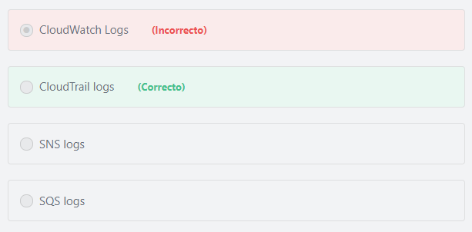

Principio del formulario

**Explicación**

        AWS CloudTrail is a web service that records all AWS API calls for your account and delivers log files to you. The recorded information includes the identity of the API caller (who deleted the buckets in our case), the time of the API call, the source IP address of the API caller, the request parameters, and the response elements returned by the AWS service. With CloudTrail, you can get a history of AWS API calls for your account, including API calls made using the AWS Management Console, AWS SDKs, command line tools, and higher-level AWS services (such as AWS CloudFormation). The AWS API call history produced by CloudTrail enables security analysis, resource change tracking, and compliance auditing.

***The other options are incorrect:***

***"SNS logs" is incorrect.*** SNS is not for logging API calls, it is a fully managed pub/sub messaging service that enables you to decouple microservices, distributed systems, and serverless applications.

***"CloudWatch Logs" is incorrect.***Amazon CloudWatch Logs are not used to record user interactions with AWS. You can use Amazon CloudWatch Logs to monitor, store, and access your log files from Amazon Elastic Compute Cloud (Amazon EC2) instances, AWS CloudTrail, Route 53, and other sources.

***"SQS logs" is incorrect.***SQS is not for logging API calls, it is a fully managed message queuing service that enables you to decouple and scale microservices, distributed systems, and serverless applications.

**References:**

<https://d1.awsstatic.com/whitepapers/aws-overview.pdf>

Final del formulario

Principio del formulario

Pregunta 9:**Incorrecto**

**Which of the following are use cases for Amazon S3? (Choose two)**

Final del formulario

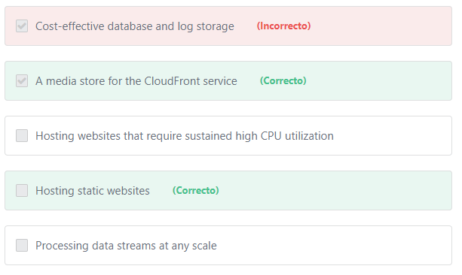

Principio del formulario

**Explicación**

              You can host a static website on Amazon Simple Storage Service (Amazon S3). On a static website, individual webpages include static content. They might also contain client-side scripts. To host a static website, you configure an Amazon S3 bucket for website hosting, allow public read access, and then upload your website content to the bucket. By contrast, a dynamic website relies on server-side processing, including server-side scripts such as PHP, JSP, or ASP.NET. Amazon S3 does not support server-side scripting. Amazon Web Services (AWS) also has resources for hosting dynamic websites such as Amazon EC2.

             Amazon S3 is an excellent storage facility for your media assets. It is infinitely scalable, has built-in redundancy, and is available to you on a pay-as-you-go basis. For example, if you want to deliver or stream video files to your global users, all you need to do is to put your content in an S3 bucket and create a CloudFront distribution that points to the bucket. Your user’s video player will use CloudFront URLs to request the video file. The request will be directed to the best edge location, based on the user’s location. The Amazon Cloudfront Content Delivery Network (CDN) will serve the video from its cache, fetching it from the S3 bucket if it has not already been cached. The CDN caches content at the edge locations for consistent, low-latency, high-throughput video delivery.

***The other options are incorrect:***

***"Cost-effective database and log storage" is incorrect.***Amazon S3 can be used to store log files, images, videos (or any static content), but not databases. Databases and dynamic websites require block-level storage (such as EBS). S3 is an object-level storage, not Block-level storage. Object-level storage has limited I/O and is therefore ill-suited for use as a database store.

***"Hosting websites that require sustained high CPU utilization" is incorrect.*** S3 can only be used to host static websites.

***"Processing data streams at any scale" is incorrect.***S3 is not a compute service.

**References:**

<https://docs.aws.amazon.com/AmazonS3/latest/dev/WebsiteHosting.html>

<https://aws.amazon.com/cloudfront/streaming/>

Final del formulario

Principio del formulario

Pregunta 10:**Correcto**

**Data security is one of the top priorities of AWS. How does AWS deal with old storage devices that have reached the end of their useful life?**

Final del formulario

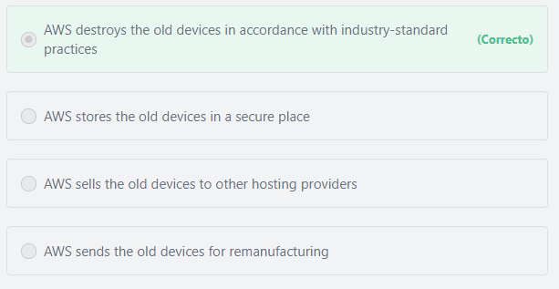

Principio del formulario

**Explicación**

         When a storage device has reached the end of its useful life, AWS procedures include a decommissioning process that is designed to prevent customer data from being exposed to unauthorized individuals. AWS uses specific techniques to destroy data as part of the decommissioning process. All decommissioned magnetic storage devices are degaussed and physically destroyed in accordance with industry-standard practices.

**References:**

<http://d1.awsstatic.com/whitepapers/Security/AWS%20Security%20Whitepaper.pdf>

Final del formulario

Principio del formulario

Pregunta 11:**Correcto**

**Which of the following AWS Services helps with planning application migration to the AWS Cloud?**

Final del formulario

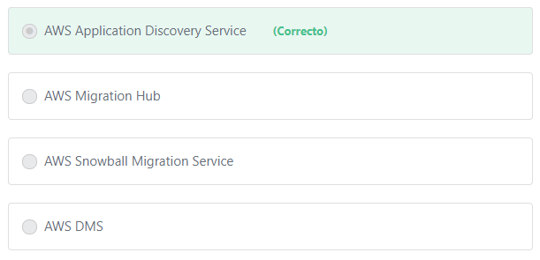

Principio del formulario

**Explicación**

         AWS Application Discovery Service helps systems integrators quickly and reliably plan application migration projects by automatically identifying applications running in on-premises data centers, their associated dependencies, and their performance profiles. Planning data center migrations can involve thousands of workloads that are often deeply interdependent. Application discovery and dependency mapping are important early first steps in the migration process, but these tasks are difficult to perform at scale due to the lack of automated tools. AWS Application Discovery Service automatically collects configuration and usage data from servers, storage, and networking equipment to develop a list of applications, how they perform, and how they are interdependent. This information helps reduce the complexity and time in planning your cloud migration.

***The other options are incorrect:***

***"AWS Migration Hub" is incorrect.***AWS Migration Hub provides a single location to track the progress of application migrations across multiple AWS and partner solutions.

***"AWS Snowball Migration Service" is incorrect.*** Snowball is a petabyte-scale data transport solution that uses secure devices to transfer large amounts of data into and out of the AWS Cloud.

***"AWS DMS" is incorrect.***AWS Database Migration Service (DMS) is used to migrate your data to and from most widely used commercial and open-source databases. AWS DMS supports homogeneous migrations such as Oracle to Oracle, as well as heterogeneous migrations between different database platforms, such as Oracle or Microsoft SQL Server to Amazon Aurora.

**References:**

<https://d1.awsstatic.com/whitepapers/aws-overview.pdf>    page 63

Final del formulario

Principio del formulario

Pregunta 12:**Incorrecto**

**What is AWS Lambda?**

Final del formulario

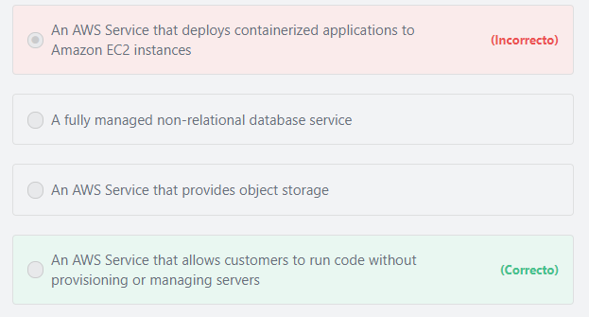

Principio del formulario

**Explicación**

             AWS Lambda lets you run code without provisioning or managing servers. You pay only for the compute time you consume - there is no charge when your code is not running. With Lambda, you can run code for virtually any type of application or backend service - all with zero administration. Just upload your code and Lambda takes care of everything required to run and scale your code with high availability.

***"An AWS Service that provides object storage" is incorrect.***Amazon S3 is the service that provides object storage.

***"An AWS Service that deploys containerized applications to Amazon EC2 instances" is incorrect.***This statement describes the Amazon Elastic Container Service (ECS) service. Amazon ECS is a container management service that allows customers to easily run containerized applications on a managed cluster of Amazon EC2 instances.

***"A fully managed non-relational database service" is incorrect.***Amazon DynamoDB is the AWS fully managed non-relational database service.

**References:**

<https://aws.amazon.com/lambda/>

Final del formulario

Principio del formulario

Pregunta 13:**Incorrecto**

**A developer needs to set up an SSL security certificate for a client's eCommerce website in order to use the HTTPS protocol. Which of the following AWS services can be used to deploy the required SSL server certificates? (Choose TWO)**

Final del formulario

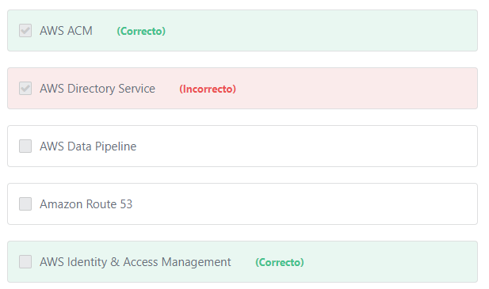

Principio del formulario

**Explicación**

               To enable HTTPS connections to your website or application in AWS, you need an SSL/TLS server certificate. You can use a server certificate provided by AWS Certificate Manager (ACM) or one that you obtained from an external provider. You can use ACM or IAM to store and deploy server certificates. Use IAM as a certificate manager only when you must support HTTPS connections in a region that is not supported by ACM. IAM supports deploying server certificates in all regions, but you must obtain your certificate from an external provider for use with AWS. Amazon Route 53 is used to register domain names or use your own domain name to route your end users to Internet applications. Route 53 is not responsible for creating SSL certifications.

***The other options are incorrect:***

***AWS Directory Service is incorrect.***AWS Directory Service is a managed Microsoft Active Directory in the AWS Cloud. Customers can use it to manage users and groups, provide single sign-on (SSO) to applications and services, as well as create and apply group policies.

**Note:**What isSingle sign-on (SSO)? Single sign-on (SSO) enables a company’s employees to sign in to AWS using their existing corporate Microsoft Active Directory credentials.

***Amazon Route 53 is incorrect.***Amazon Route 53 can be used for registering domain names, routing end users to Internet applications, configuring DNS health checks to route traffic to healthy endpoints, managing traffic globally through a variety of routing types etc.

***AWS Data Pipeline is incorrect.*** AWS Data Pipeline is a web service that helps you reliably process and move data between different AWS compute and storage services, as well as on-premises data sources. AWS Data Pipeline integrates with on-premise and cloud-based storage systems to allow developers to use their data when they need it, where they want it, and in the required format.

**References:**

<https://aws.amazon.com/certificate-manager/>

<https://docs.aws.amazon.com/IAM/latest/UserGuide/id_credentials_server-certs.html>

<https://aws.amazon.com/route53/>

Final del formulario

Principio del formulario

Pregunta 14:**Incorrecto**

**How do ELBs improve the reliability of your application?**

Final del formulario

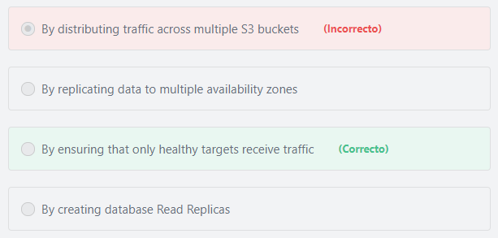

Principio del formulario

**Explicación**

            The reliability term encompasses the ability of a system to recover from infrastructure or service disruptions, and dynamically acquire computing resources to meet demand. ELBs continuously perform health checks on the registered targets (such as Amazon EC2 instances) and only routes traffic to the healthy ones. This increases the fault tolerance of your application and makes it more reliable.

***The other options are incorrect:***

***"By replicating data to multiple availability zones" is incorrect.*** ELBs are not responsible for replicating data.

***"By creating database Read Replicas" is incorrect.*** Read Replicas are special types of database instances that are part of Amazon RDS NOT ELB. The purpose of Read Replicas on Amazon RDS is to enhance database performance and increase database availability.

***"By distributing traffic across multiple S3 buckets" is incorrect.*** There is no need to create multiple S3 buckets and distribute traffic between them; One S3 bucket can handle any amount of traffic without any intervention. Amazon S3 was designed from the ground up to handle traffic for any Internet application. Amazon S3’s massive scale allows to spread load evenly, so that no individual application is affected by traffic spikes.

**References:**

<https://aws.amazon.com/elasticloadbalancing/>

Final del formulario

Principio del formulario

Pregunta 15:**Incorrecto**

**What are the benefits of using the Amazon Relational Database Service? (Choose two)**

Final del formulario

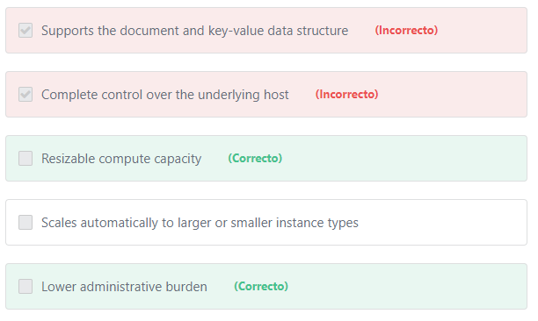

Principio del formulario

**Explicación**

          Amazon Relational Database Service (Amazon RDS) makes it easy to set up, operate, and scale a relational database in the cloud. It provides cost-efficient and resizable Compute (and\or Storage) capacity while automating time-consuming administration tasks such as hardware provisioning, operating system maintenance, database setup, patching and backups. It frees you to focus on your applications so you can give them the fast performance, high availability, security and compatibility they need.

***The other options are incorrect:***

***"Complete control over the underlying host" is incorrect.*** The user doesn’t have access to the underlying host. For managed services like this, AWS is responsible for performing all the operations needed to keep the service running.

***"Supports the document and key-value data structure" is incorrect.*** RDS doesn’t support document and key-value data structures. The AWS service that support them is DynamoDB.

***"Scales automatically to larger or smaller instance types" is incorrect.***Amazon RDS provides you with six widely-used database engines to choose from, including Amazon Aurora, PostgreSQL, MySQL, MariaDB, Oracle Database, and SQL Server. The only RDS database that can scale instances automatically is Amazon Aurora.

**Additional information:**

For RDS databases other than Aurora, RDS only supports storage auto-scaling, NOT instance auto-scaling. If you want to scale Amazon RDS instances (other than Aurora), you have two options:

1- Manual horizontal scaling (by adding read replicas)

2- Manual vertical scaling (by upgrading/downgrading an existing instance).

**References:**

<https://aws.amazon.com/nosql/>

<https://aws.amazon.com/rds/>

<https://aws.amazon.com/blogs/database/scaling-your-amazon-rds-instance-vertically-and-horizontally/>

Final del formulario

Principio del formulario

Pregunta 16:**Incorrecto**

**Which support plan includes AWS Support Concierge Service?**

Final del formulario

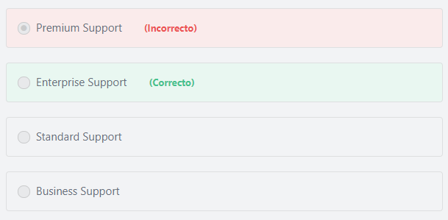

Principio del formulario

**Explicación**

The AWS Support Concierge Service is available only for the Enterprise plan subscribers.

**References:**

<https://aws.amazon.com/premiumsupport/features/>

Final del formulario

Principio del formulario

Pregunta 17:**Correcto**

**​ For managed services like Amazon DynamoDB, which of the below is AWS responsible for? (Choose two)**

Final del formulario

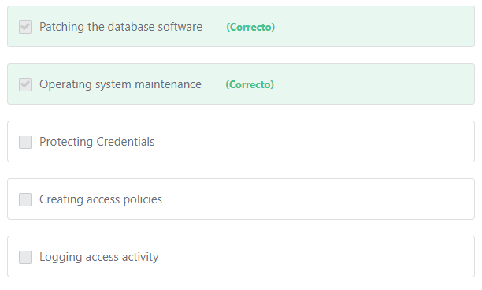

Principio del formulario

**Explicación**

                 AWS has increased responsibilities for its managed services. Examples of managed services include Amazon DynamoDB, Amazon RDS, Amazon Redshift, Amazon Elastic MapReduce, and Amazon WorkSpaces. These services provide the scalability and flexibility of cloud-based resources with less operational overhead because AWS handle basic security tasks like guest operating system (OS) and database patching, installing antivirus software, backup, and disaster recovery. For most managed services, you only configure logical access controls and protect account credentials, while maintaining control and responsibility of any personal data.

**Note:**

If you are using Amazon EC2 instead of the AWS managed services to run your databases and applications, you will be responsible for performing all of the necessary security configuration and management tasks.

***The other options are incorrect:***

***"Creating access policies" is incorrect.***The customer is responsible for creating the required access policies for all users using the Identity and Access Management service.

***"Protecting Credentials" is incorrect.***The customer (or anyone in his team) is responsible for protecting their credentials.

***"Logging access activity" is incorrect.***Logging user access activities is the responsibility of the customer, whether he is using a managed service or any other services. The AWS customer can use AWS CloudTrail to record and monitor all API calls made in his AWS account.

**References:**

<https://d1.awsstatic.com/whitepapers/Security/AWS_Security_Whitepaper.pdf>

<https://aws.amazon.com/compliance/shared-responsibility-model/>

Final del formulario

Principio del formulario

Pregunta 18:**Correcto**

**Which of the following statements describes the AWS Cloud’s agility?**

Final del formulario

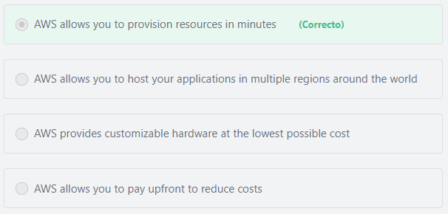

Principio del formulario

**Explicación**

            In a cloud computing environment, new IT resources are only a click away, which means that you reduce the time to make those resources available to your developers from weeks (or months in some cases) to just minutes. This results in a dramatic increase in agility for the organization, since the cost and time it takes to experiment and develop is significantly lower.

           In other words, instead of waiting weeks or months for hardware, you can instantly deploy new applications. Also, whether you need one virtual server or thousands, whether you need them for a few hours or 24/7, you still only pay for what you use.

***The other options are incorrect:***

***"AWS provides customizable hardware at the lowest possible cost" is incorrect.***AWS doesn’t provide customizable hardware. AWS offers cloud computing services.

***"AWS allows you to pay upfront to reduce costs" is incorrect.*** This statement is much more related to AWS reservations, not agility.

***"AWS allows you to host your applications in multiple regions around the world" is incorrect.*** It is true that AWS provides global infrastructure, but this statement doesn’t describe AWS’ agility.

**References:**

<https://aws.amazon.com/what-is-cloud-computing/>

<https://docs.aws.amazon.com/aws-technical-content/latest/aws-overview/six-advantages-of-cloud-computing.html>

Final del formulario

Principio del formulario

Pregunta 19:**Incorrecto**

**Which of the following AWS services scale automatically without your intervention? (Choose two)**

Final del formulario

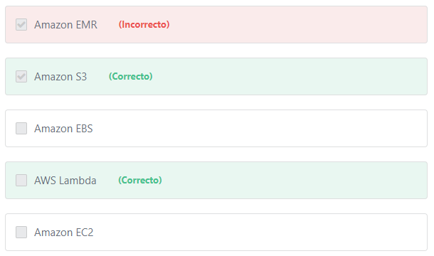

Principio del formulario

**Explicación**

Amazon S3 and Amazon EFS are storage services that scale automatically in storage capacity without any intervention to meet increased demand.

Also, AWS Lambda dynamically scales function execution in response to increased traffic.

***The other options are incorrect:***

***Amazon EMR is incorrect.***Amazon EMR doesn’t scale on its own. You have to configure the AWS Auto Scaling feature to scale EMR automatically.

***Amazon EC2 is incorrect.***Amazon EC2 does scale automatically, but first you have to create an Auto Scaling system by creating a launch configuration, an auto scaling group, and determine the desired, minimum and maximum number of instances to provision.

***Amazon EBS is incorrect.***Amazon Elastic Block Store (Amazon EBS) provides persistent block level storage volumes for use with Amazon EC2 instances in the AWS Cloud.

**References:**

<https://d1.awsstatic.com/whitepapers/aws-overview.pdf>

Final del formulario

Principio del formulario

Pregunta 20:**Incorrecto**

**A company is trying to analyze the costs applied to their AWS account recently. Which of the following provides them the most granular data about their AWS costs and usage?**

Final del formulario

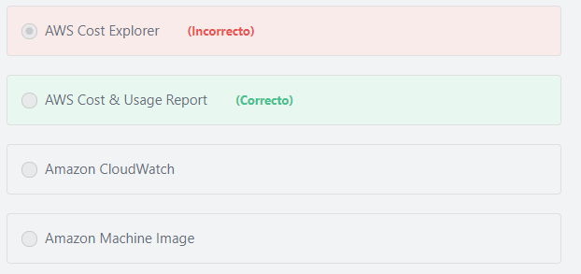

Principio del formulario

**Explicación**

              The AWS Cost & Usage Report contains the most comprehensive set of AWS cost and usage data available, including additional metadata about AWS services, pricing, and reservations (e.g., Amazon EC2 Reserved Instances (RIs)). The AWS Cost and Usage Report tracks your AWS usage and provides information about your use of AWS resources and estimated costs for that usage. You can configure this report to present the data hourly or daily. It is updated at least once a day until it is finalized at the end of the billing period. The AWS Cost and Usage Report gives you the most granular insight possible into your costs and usage, and it is the source of truth for the billing pipeline. It can be used to develop advanced custom metrics using business intelligence, data analytics, and third-party cost optimization tools.

***"Amazon CloudWatch" is incorrect.***Amazon CloudWatch is a monitoring service for AWS cloud resources and the applications you run on AWS. You can use Amazon CloudWatch to collect and track metrics, collect and monitor log files, set alarms, and automatically react to changes in your AWS resources. Amazon CloudWatch can monitor AWS resources such as Amazon EC2 instances, Amazon DynamoDB tables, and Amazon RDS DB instances, as well as custom metrics generated by your applications and services, and any log files your applications generate. You can use Amazon CloudWatch to gain system-wide visibility into resource utilization, application performance, and operational health. You can use these insights to react and keep your application running smoothly.

***"Amazon Machine Image" is incorrect.***AnAmazon Machine Image is used to launch Amazon EC2 instances.

***"AWS Cost Explorer" is incorrect.***AWS Cost Explorer helps you visualize, understand, and manage your AWS costs and usage over time. This is done via an intuitive interface that enables you to quickly create custom reports that include charts and tabular data. You can analyze your cost and usage data in aggregate (such as total costs and usage across all accounts) down to granular details (for example, m2.2xlarge costs within the Dev account tagged “project: Blackthorn”). This option is incorrect because the AWS Cost & Usage Report provides more granular data about your AWS costs and usage than what the AWS Cost Explorer provides. The AWS Cost & Usage Report is your one-stop shop for accessing the most detailed information available about your AWS costs and usage.

**References:**

<https://docs.aws.amazon.com/whitepapers/latest/cost-management/getting-started-with-cost-management.html>

Final del formulario

Principio del formulario

Pregunta 21:**Incorrecto**

**A company needs to track resource changes using the API call history. Which AWS service can help the company achieve this goal?**

Final del formulario

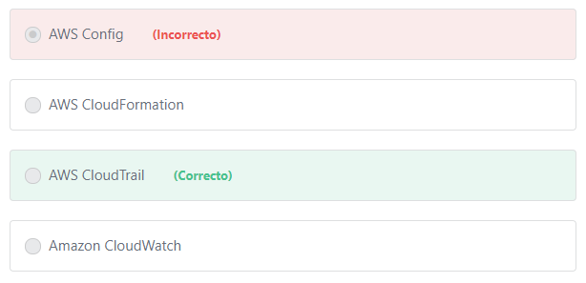

Principio del formulario

**Explicación**

          AWS CloudTrail is a web service that records AWS API calls for your account and delivers log files to you. The recorded information includes the identity of the API caller, the time of the API call, the source IP address of the API caller, the request parameters, and the response elements returned by the AWS service.  With CloudTrail, you can get a history of AWS API calls for your account, including API calls made using the AWS Management Console, AWS SDKs, command line tools, and higher-level AWS services (such as AWS CloudFormation). The AWS API call history produced by CloudTrail enables security analysis, resource change tracking, and compliance auditing.

***The other options are incorrect:***

***AWS Config is incorrect.***

              Both AWS Config and AWS CloudTrail can be used to track resource changes, and it is very important to distinguish between them. AWS Config is used to monitor and audit changes in AWS resources and allow you to automate the evaluation of recorded configurations of a specific resource against desired configurations. AWS CloudTrail records user API activity on your account and allows you to access information about this activity. You get full details about API actions, such as identity of the caller, the time of the API call, the request parameters, and the response elements returned by the AWS service.

             AWS Config records point-in-time configuration details for your AWS resources as Configuration Items (CIs). You can use a CI to answer “What did my AWS resource look like?” at a point in time. You can use AWS CloudTrail to answer “Who made an API call to modify this resource?” For example, you can use the AWS Management Console for AWS Config to detect security group “Production-DB” was incorrectly configured in the past. Using the integrated AWS CloudTrail information, you can pinpoint which user misconfigured “Production-DB” security group. In brief, AWS Config provides information about the changes made to a resource, and AWS CloudTrail provides information about who made those changes.

***AWS CloudFormation is incorrect.***AWS CloudFormation is a service that allows you to use a simple text file to model and provision, in an automated and secure manner, all the resources needed for your applications across all regions and accounts.

***Amazon CloudWatch is incorrect.*** Amazon CloudWatch is used to monitor and collect custom and granular metrics about your AWS resources.

**References:**

<https://d1.awsstatic.com/whitepapers/aws-overview.pdf>

Final del formulario

Principio del formulario

Pregunta 22:**Incorrecto**

**What is one benefit and one drawback of buying a reserved EC2 instance? (Select TWO)**

Final del formulario

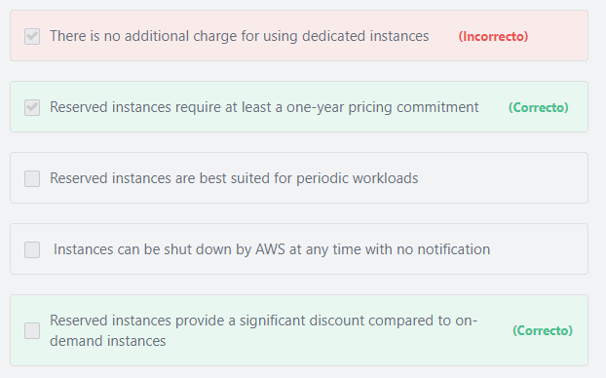

Principio del formulario

**Explicación**

                Amazon EC2 Reserved Instances (RI) provide a significant discount (up to 75%) compared to On-Demand pricing. Reserved instances can be purchased for a 1-year or 3-year term so you are committing to pay for them throughout this time period even if you don’t use them.

***The other options are incorrect:***

***"Reserved instances are best suited for periodic workloads" is incorrect.***Reserved instances are not suitable for periodic workloads. You should use On-Demand instances instead.

***"There is no additional charge for using dedicated instances" is incorrect.*** Dedicated instances are a different EC2 option.

***"***​ ***Instances can be shut down by AWS at any time with no notification" is incorrect.***AWS can interrupt Spot Instances ;not reserved instances. Spot Instances can be shut down by AWS when the Spot price exceeds the maximum price, when the demand for Spot Instances rises, or when the supply of Spot Instances decreases.

**References:**

<https://aws.amazon.com/ec2/pricing/reserved-instances/pricing/>

Final del formulario

Principio del formulario

Pregunta 23:**Incorrecto**

**AWS recommends some practices to help organizations avoid unexpected charges on their bill. Which of the following is NOT one of these practices?**

Final del formulario

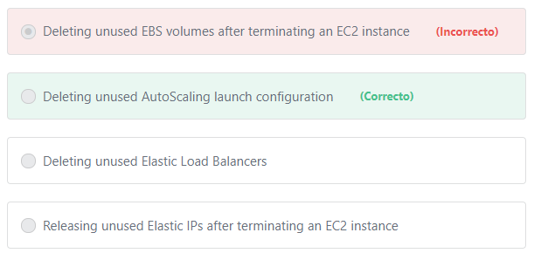

Principio del formulario

**Explicación**

           "***Deleting unused AutoScaling launch configuration***" will not help, and thus is the correct choice. The AutoScaling launch configuration does not incur any charges. Thus, it will not make any difference whether it is deleted or not.

           AWS will charge the user once the AWS resource is allocated (even if it is not used). Thus, it is advised that once the user's work is completed he should:

1- Delete all Elastic Load Balancers.

2- Terminate all unused EC2 instances.

3- Delete the attached EBS volumes that he doesn’t need.

4- Release any unused Elastic IPs.

**Additional information:**

Some services automatically restart resources after terminating them without notifying you, and as a result, you get unexpected charges on your bill.

Examples of these services:

1- Elastic Beanstalk:

Elastic Beanstalk is designed to ensure that all the resources that you need are running, which means that it automatically relaunches any service that you stop. If you need to permanently delete those resources you must terminate your Elastic Beanstalk environment before you terminate resources that Elastic Beanstalk has created.

2- AWS OpsWorks:

If you use the AWS OpsWorks environment to create AWS resources, you must use AWS OpsWorks to terminate those resources or AWS OpsWorks will restart them. For example, if you use AWS OpsWorks to create an Amazon EC2 instance, but then stop it by using the Amazon EC2 console, the AWS OpsWorks auto-healing feature categorizes the instance as failed and restarts it.

**References:**

<https://aws.amazon.com/autoscaling/pricing/>

Final del formulario

Principio del formulario

Pregunta 24:**Incorrecto**

**What are the benefits of implementing a tagging strategy for AWS resources? (Choose two)**

Final del formulario

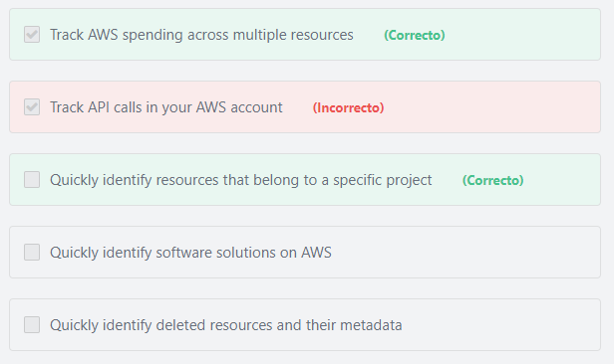

Principio del formulario

**Explicación**

               Amazon Web Services (AWS) allows customers to assign metadata to their AWS resources in the form of tags. Each tag is a simple label consisting of a customer-defined key and an optional value that can make it easier to manage, search for, and filter resources. Although there are no inherent types of tags, they enable customers to categorize resources by purpose, owner, environment, or other criteria. An effective tagging strategy will give you improved visibility and monitoring, help you create accurate chargeback/showback models, and get more granular and precise insights into usage and spend by applications and teams.

***The other options are incorrect:***

***"Track API calls in your AWS account" is incorrect.***AWS CloudTrail is the service that can be used to track API calls in your AWS account.

***"Quickly identify deleted resources and their metadata" is incorrect.***You cannot use tags to find deleted resources. Also, once you delete a resource, all its metadata will be deleted with it.

***"Quickly identify*** ***software solutions on AWS" is incorrect.*** The AWS marketplace is the service that allows you to search for software solutions on AWS.

**References:**

<https://docs.aws.amazon.com/aws-technical-content/latest/cost-optimization-laying-the-foundation/tagging.html>

Final del formulario

Principio del formulario

Pregunta 25:**Incorrecto**

**What AWS tools can be used to call AWS Services from different programming languages?**

Final del formulario

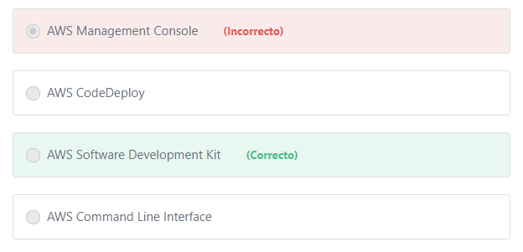

Principio del formulario

**Explicación**

              The AWS Software Development Kit (AWS SDK) can simplify using AWS services in your applications with an API tailored to your programming language or platform. Programming languages supported include Java, .NET, Node.js, PHP, Python, Ruby, Go, and C++.

***The other options are incorrect:***

***"AWS CodeDeploy" is incorrect.***AWS CodeDeploy is a deployment service that automates application deployments to Amazon EC2 instances, on-premises instances, serverless Lambda functions, or Amazon ECS services.

***"AWS Management Console" is incorrect.***AWS management Console allows you to manage AWS services through a web-based user interface.

***"AWS Command Line Interface" is incorrect.*** AWS Command Line Interface (AWS CLI) allows you to control multiple AWS services from the command line and automate them through scripts NOT from programming languages.

**References:**

<https://aws.amazon.com/getting-started/tools-sdks/>

<https://aws.amazon.com/tools/>

<https://aws.amazon.com/cli/>

Final del formulario

Principio del formulario

Pregunta 26:**Incorrecto**

**What is the main purpose of using Amazon SWF?**

Final del formulario

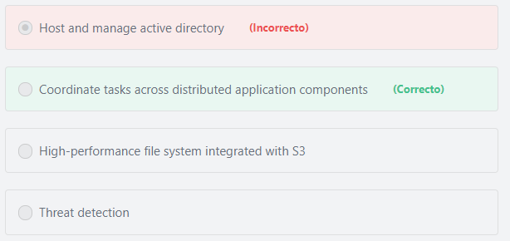

Principio del formulario

**Explicación**

            Amazon Simple Workflow Service (SWF) is a web service that makes it easy to coordinate work across distributed application components. Amazon SWF enables applications for a range of use cases, including media processing, web application back-ends, business process workflows, and analytics pipelines, to be designed as a coordination of tasks. Tasks represent invocations of various processing steps in an application which can be performed by executable code, web service calls, human actions, and scripts. The coordination of tasks involves managing execution dependencies, scheduling, and concurrency in accordance with the logical flow of the application. With Amazon SWF, developers get full control over implementing processing steps and coordinating the tasks that drive them, without worrying about underlying complexities such as tracking their progress and keeping their state.

**References:**

<https://aws.amazon.com/swf/>

Final del formulario

Principio del formulario

Pregunta 27:**Correcto**

**Which AWS service provides cost-optimization recommendations?**

Final del formulario

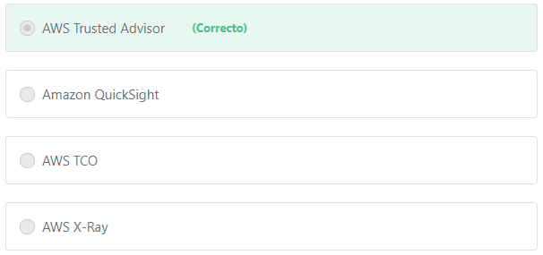

Principio del formulario

**Explicación**

              AWS Trusted Advisor is an application that draws upon best practices learned from AWS’ aggregated operational history of serving hundreds of thousands of AWS customers. Trusted Advisor inspects your AWS environment and makes recommendations that can potentially save you money by highlighting unused resources and opportunities to reduce your bill. AWS Trusted Advisor also provide recommendations to improve system performance, and close security gaps.

***The other options are incorrect:***

***"Amazon QuickSight" is incorrect.***Amazon QuickSight is a very fast, easy-to-use, cloud-powered business analytics service that makes it easy for all employees within an organization to build visualizations, perform ad-hoc analysis, and quickly get business insights from their data, anytime, on any device. Unlike traditional BI or data discovery solutions, getting started with Amazon QuickSight is simple and fast. When you log in, Amazon QuickSight seamlessly discovers your data sources in AWS services such as Amazon Redshift, Amazon RDS, Amazon Athena, and Amazon Simple Storage Service (Amazon S3). You can connect to any of the data sources discovered by Amazon QuickSight and get insights from this data in minutes. Amazon QuickSight supports rich data discovery and business analytics capabilities to help customers derive valuable insights from their data without worrying about provisioning or managing infrastructure. Organizations pay a low monthly fee for each Amazon QuickSight user, eliminating the cost of long-term licenses. With Amazon QuickSight, organizations can deliver rich business analytics functionality to all employees without incurring a huge cost upfront.

***"AWS X-Ray" is incorrect.*** AWS X-Ray can be used to analyze and debug your production applications and helps you understand how your application and its underlying services are performing to identify and troubleshoot the root cause of performance issues and errors.

***"AWS TCO" is incorrect.***The AWS TCO calculator does not provide cost-optimization recommendations. It helps you evaluate the savings from using AWS and compare an AWS Cloud environment to on-premises and co-location environments. This tool considers all the costs to run a solution, including physical facilities, power, and cooling, to provide a realistic, end-to-end comparison of your costs.

**References:**

<https://aws.amazon.com/premiumsupport/trustedadvisor/>

Final del formulario

Principio del formulario

Pregunta 28:**Incorrecto**

**TYMO Cloud Corp is looking forward to migrating their entire on-premises data center to AWS. What tool can they use to perform a cost-benefit analysis of moving to the AWS Cloud?**

Final del formulario

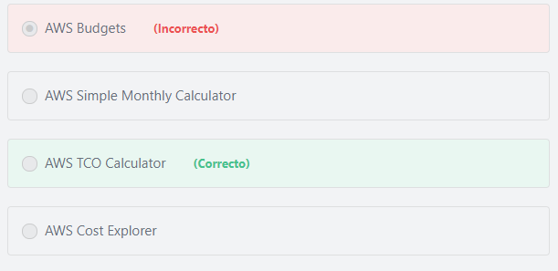

Principio del formulario

**Explicación**

          The AWS TCO (Total Cost of Ownership) Calculator is a free tool that provides directional guidance on possible realized savings when deploying AWS. This tool is built on an underlying calculation model, that generates a fair assessment of value that a customer may achieve given the data provided by the user which includes the number of servers migrated to AWS, the server type, the number of processors and so on.

***The other options are incorrect:***

***"AWS Simple Monthly Calculator" is incorrect.*** The AWS Simple Monthly Calculator helps customers estimate their monthly AWS bill based on their expected usage.

***"AWS Cost Explorer" is incorrect.***Cost Explorer is a tool that enables you to view and analyze your current AWS costs and usage.

***"AWS Budgets" is incorrect.***AWS Budgets gives you the ability to set custom budgets that alert you when your costs or usage exceed (or are forecasted to exceed) your budgeted amount.

**References:**

<https://aws.amazon.com/tco-calculator/>

Final del formulario

Principio del formulario

Pregunta 29:**Incorrecto**

**What is the AWS tool that can help a company visualize their AWS spending in the last few months?**

Final del formulario

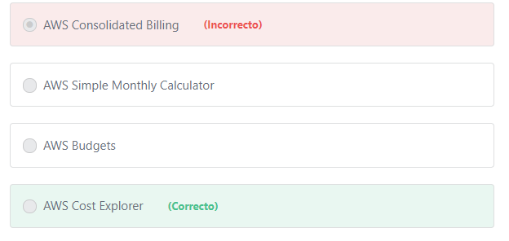

Principio del formulario

**Explicación**

               The AWS Billing and Cost Management console includes the Cost Explorer tool for viewing AWS cost data as a graph. The user can filter the graphs using the resource tags. If the company is using Consolidated Billing, it generates a report based on the linked accounts which can help to identify areas that require further inquiry. Using the Cost Explorer, the company can view trends and use them to understand their spending and to predict future costs.

***The other options are incorrect:***

***"AWS Simple Monthly Calculator" is incorrect.***The AWS Simple Monthly Calculator helps customers and prospects **estimate** their monthly AWS bill more efficiently.

***"AWS Consolidated Billing" is incorrect.***Consolidated billing is a feature in AWS Organizations that you can use to consolidate billing and payment for multiple AWS accounts.

***"AWS Budgets" is incorrect.*** AWS Budgets allows you to set custom budgets that alert you when you exceed your budgeted thresholds.

**References:**

<https://aws.amazon.com/aws-cost-management/aws-cost-explorer/>

Final del formulario

Principio del formulario

Pregunta 30:**Incorrecto**

**​ A customer spent a lot of time configuring a newly deployed Amazon EC2 instance. After the workload increases, the customer decides to provision another EC2 instance with an identical configuration. How can the customer achieve this?**

Final del formulario

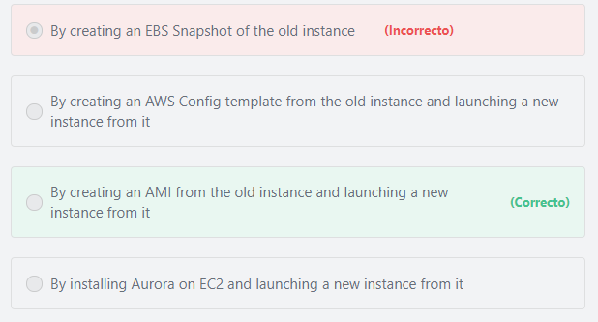

Principio del formulario

**Explicación**

            An Amazon Machine Image (AMI) provides the information required to launch an instance, which is a virtual server in the cloud. You must specify an AMI when you launch an instance, and you can launch as many instances from the AMI as you need. You can also launch instances from as many different AMIs as you need.

***The other options are incorrect:***

***"By installing Aurora on EC2 and launching a new instance from it" is incorrect.***Amazon Aurora is a database service. You cannot use it to launch EC2 instances. Also, you cannot install Aurora on EC2. Aurora is a managed service that is already installed on the AWS Cloud. You can launch Amazon Aurora using the Amazon RDS Management Console.

***"By creating an EBS Snapshot of the old instance" is incorrect.*** Amazon EBS Snapshots are just backups for EBS volumes.

***"By creating an AWS Config template from the old instance and launching a new instance from it" is incorrect.*** AWS Config is used to record and evaluate configurations of your AWS resources, and is not used to launch new instances.

**References:**

<https://docs.aws.amazon.com/AWSEC2/latest/UserGuide/AMIs.html>

Final del formulario

Principio del formulario

Pregunta 31:**Incorrecto**

**A company needs to migrate their website from on-premises to AWS. Security is a major concern for them, so they need to host their website on hardware that is NOT shared with other AWS customers. Which of the following EC2 instance options meets this requirement?**

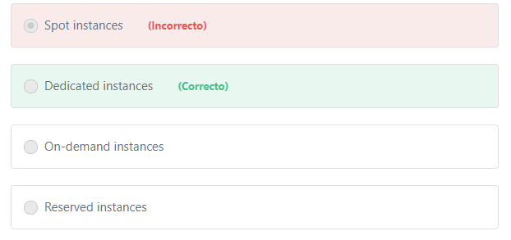Final del formulario

Principio del formulario

**Explicación**

               Dedicated Instances are Amazon EC2 instances that run in a virtual private cloud (VPC) on hardware that's dedicated to a single customer. Dedicated Instances that belong to different AWS accounts are physically isolated at the hardware level. In addition, Dedicated Instances that belong to AWS accounts that are linked to a single payer account are also physically isolated at the hardware level. However, Dedicated Instances may share hardware with other instances from the same AWS account that are not Dedicated Instances.

***The other options are incorrect:***

***"Reserved instances" and "Spot instances" and "On-demand instances" are incorrect.***Reserved, Spot and On-demand instances all share hardware with other customers.

**References:**

<https://docs.aws.amazon.com/AWSEC2/latest/UserGuide/dedicated-instance.html>

Final del formulario

Principio del formulario

Pregunta 32:**Correcto**

**What is the AWS service that provides five times the performance of a standard MySQL database?**

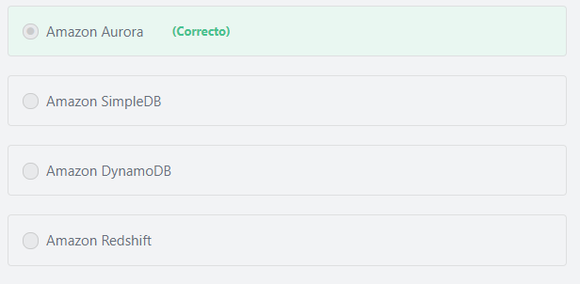Final del formulario

Principio del formulario

**Explicación**

             Amazon Aurora is a fully-managed, MySQL and PostgreSQL-compatible relational database engine. It combines the speed and reliability of high-end commercial databases with the simplicity and cost-effectiveness of open-source databases. It delivers up to five times the throughput of MySQL and up to three times the throughput of PostgreSQL without requiring changes to most of your existing applications.

***The other options are incorrect:***

***Amazon Redshift is incorrect.***Amazon Redshift is a data warehousing service.

***Amazon SimpleDB is incorrect.***Amazon SimpleDB is a NoSQL data store.

***Amazon DynamoDB is incorrect.***AmazonDynamoDB is a NoSQL database engine.

**References:**

<https://aws.amazon.com/rds/aurora/>

Final del formulario

Principio del formulario

Pregunta 33:**Incorrecto**

**What does AWS offer to secure your network?**

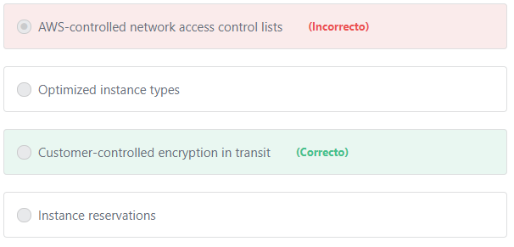Final del formulario

Principio del formulario

**Explicación**

       Data in transit (sometimes called data in motion) is a term used to describe data that is in transit through networks. Encrypting data in transit will add more security to your network by ensuring that data is unreadable as it travels from a service to another or from a network to another. The AWS Customer is responsible for encrypting their data either in transit or at rest.

Note: Data at rest is the data that is not actively moving from device to device or network to network such as data stored on disks in AWS data centers.

***The other options are incorrect:***

***"AWS-controlled network access control lists" is incorrect.***Network access control lists are customer-controlled, NOT AWS-controlled.

***"Optimized instance types" is incorrect.***There is no relation between the instance types and network security. Customers select an instance type based on the performance requirements, NOT security.

***"Instance reservations" is incorrect.*** There is no relation between the instance reservations and network security. Customers may reserve Compute capacity to get more discounts. For example, Amazon EC2 Reserved Instances (RI) provide a significant discount (up to 75%) compared to On-Demand instance pricing.

**References:**

<https://d1.awsstatic.com/whitepapers/architecture/AWS_Well-Architected_Framework.pdf>

Final del formulario

Principio del formulario

Pregunta 34:**Correcto**

**App development companies move their business to AWS to reduce time-to-market and improve customer satisfaction, what are the AWS automation tools that help them deploy their applications faster? (Choose two)**

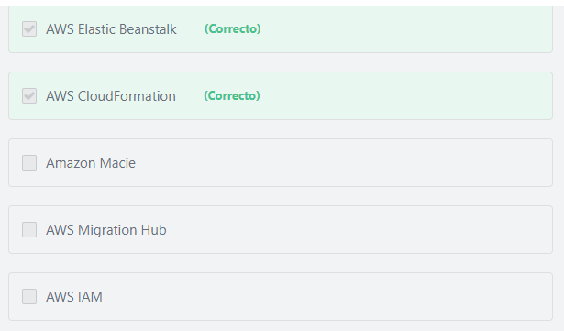Final del formulario

Principio del formulario

**Explicación**

            AWS Elastic Beanstalk makes it easier for developers to quickly deploy and manage applications in the AWS Cloud. Developers simply upload their application, and Elastic Beanstalk automatically handles the deployment details of capacity provisioning, load balancing, auto-scaling, and application health monitoring.

          AWS CloudFormation automates and simplifies the task of repeatedly and predictably creating groups of related resources that power your applications. Creating and interconnecting all resources your application needs to run is now as simple as creating a single EC2 or RDS instance.

***The other options are incorrect.***

***Amazon Macie is incorrect.***Amazon Macie is a security service that uses machine learning to automatically discover, classify, and protect sensitive data in AWS. Amazon Macie recognizes sensitive data such as personally identifiable information (PII) or intellectual property, and provides you with dashboards and alerts that give visibility into how this data is being accessed or moved.

***AWS IAM is incorrect.***AWS Identity and Access Management (IAM) enables you to manage access to AWS services and resources securely. Using IAM, you can create and manage AWS users and groups, and use permissions to allow and deny their access to AWS resources.

***AWS Migration Hub is incorrect.***AWS Migration Hub is used to track the progress of application migrations to AWS.

**References:**

<https://aws.amazon.com/elasticbeanstalk/>

<https://aws.amazon.com/cloudformation/>

Final del formulario

Principio del formulario

Pregunta 35:**Incorrecto**

**What are the benefits of using DynamoDB? (Choose TWO)**

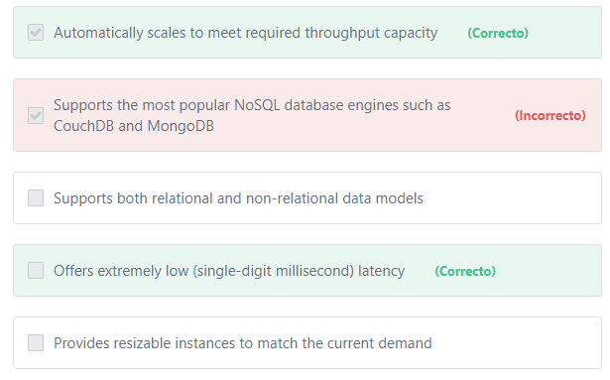Final del formulario

Principio del formulario

**Explicación**

Benefits of DynamoDB include:

1- Performance at scale:

DynamoDB supports some of the world’s largest scale applications by providing consistent, single-digit millisecond response times at any scale. You can build applications with virtually unlimited throughput and storage.

2- Serverless:

With DynamoDB, there are no servers to provision, patch, or manage and no software to install, maintain, or operate. DynamoDB automatically scales tables up and down to adjust for capacity and maintain performance.

3- Highly available:

Availability and fault tolerance are built in, eliminating the need to architect your applications for these capabilities.

***The other options are incorrect:***

***"Supports the most popular NoSQL database engines such as CouchDB and MongoDB" is incorrect.*** DynamoDB does not use or support any other NoSQL database engines. You only have access to DynamoDB's built-in engine.

***"Supports both relational and non-relational data models" is incorrect.***DynamoDB only supports the non-relational data model.

***"Provides resizable instances to match the current demand" is incorrect.***DynamoDB does not provide instances (servers). DynamoDB is serverless with no servers to provision, patch, or manage and no software to install, maintain, or operate. DynamoDB automatically scales tables up and down to adjust for capacity and maintain performance.

**References:**

<https://d1.awsstatic.com/whitepapers/aws-overview.pdf>

Final del formulario

Principio del formulario

Pregunta 36:**Incorrecto**

**A customer is planning to move billions of images and videos to be stored on Amazon S3. The customer has approximately one Exabyte of data to move. Which of the following AWS Services is the best choice to transfer the data to AWS?**

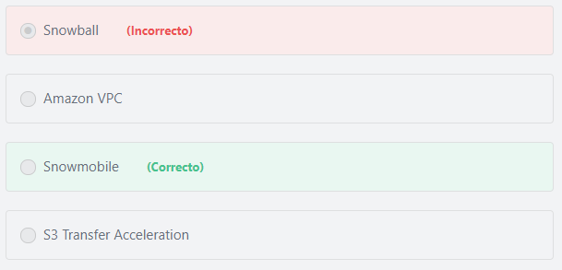Final del formulario

Principio del formulario

**Explicación**

         AWS Snowmobile is an Exabyte-scale data transfer service used to move extremely large amounts of data to AWS. You can transfer up to 100 Petabytes (PB) per Snowmobile, a 45-foot long ruggedized shipping container, pulled by a semi-trailer truck. Snowmobile makes it easy to move massive volumes of data to the cloud, including video libraries, image repositories, or even a complete data center migration. At exabyte scale, transferring data with Snowmobile is more secure, fast and cost effective.

***The other options are incorrect:***

***Amazon VPC is incorrect.*** Amazon VPC is used to create virtual networks in the cloud.

***Snowball is incorrect.***AWS Snowball is a data transport solution that accelerates moving terabytes to petabytes of data into and out of AWS using storage devices designed to be secure for physical transport. Customers can transfer up to 80 Terabytes per Snowball. In our case, the customer needs to move 1 Exabyte of data (or 1000,000 Terabytes), so it is better to use the AWS Snowmobile service.

***S3 Transfer Acceleration is incorrect.***Amazon S3 Transfer Acceleration is not a migration solution. Amazon S3 Transfer Acceleration enables fast transfers of files over long distances between your client and an S3 bucket. Transfer Acceleration takes advantage of Amazon CloudFront’s globally distributed edge locations. As the data arrives at an edge location, data is routed to Amazon S3 over an optimized network path.

**References:**

<https://aws.amazon.com/snowmobile/>

Final del formulario

Principio del formulario

Pregunta 37:**Incorrecto**

**Which of the following AWS services can help you perform security analysis and regulatory compliance auditing? (Choose two)**

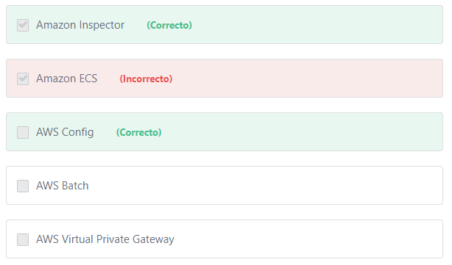Final del formulario

Principio del formulario

**Explicación**

             With AWS Config, you can discover existing and deleted AWS resources, determine your overall compliance against rules, and dive into configuration details of a resource at any point in time. These capabilities enable compliance auditing, security analysis, resource change tracking, and troubleshooting.

             Amazon Inspector is an automated security assessment service that helps improve the security and compliance of applications deployed on AWS. Amazon Inspector automatically assesses applications for exposure, vulnerabilities, and deviations from best practices. This allows you to make security testing a more regular occurrence as part of development and IT operations.

Additional information:

One of the most important services that performs security analysis and compliance auditing is AWS CloudTrail. AWS CloudTrail simplifies your compliance audits by automatically recording and storing event logs for actions made within your AWS account. With AWS CloudTrail, you can discover and troubleshoot security and operational issues by capturing a comprehensive history of changes that occurred in your AWS account within a specified period of time.

***The other options are incorrect:***

***"AWS Virtual Private Gateway" is incorrect.***AWS Virtual Private Gateway allows creating hybrid cloud architecture by connecting your data center (or network) to your Amazon virtual private cloud (VPC).

***"Amazon ECS" is incorrect.***Amazon Elastic Container Service (Amazon ECS) is a compute service that allows you to run and scale containerized applications on AWS.

***"AWS Batch" is incorrect.***AWS Batch is a compute service that allows you to run hundreds of thousands of batch computing jobs on AWS. AWS Batch dynamically provisions the optimal quantity and type of compute resources (e.g., CPU or memory optimized instances) based on the volume and specific resource requirements of the batch jobs submitted.

**References:**

<https://d1.awsstatic.com/whitepapers/aws-overview.pdf>

Final del formulario

Principio del formulario

Pregunta 38:**Incorrecto**

**What does AWS Service Catalog provide?**

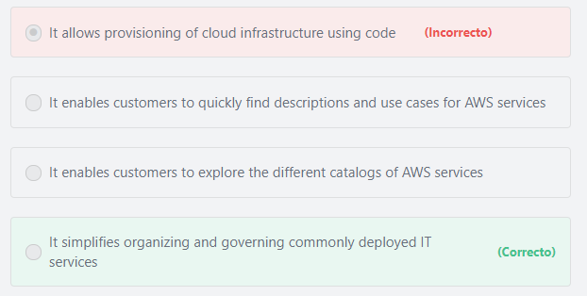Final del formulario

Principio del formulario

**Explicación**

               AWS Service Catalog allows organizations to create and manage catalogs of IT services that are approved for use on AWS. These IT services can include everything from virtual machine images, servers, software, and databases to complete multi-tier application architectures. AWS Service Catalog allows you to centrally manage commonly deployed IT services, and helps you achieve consistent governance and meet your compliance requirements, while enabling users to quickly deploy only the approved IT services they need.

***The other options are incorrect:***

***"It enables customers to explore the different catalogs of AWS services" is incorrect.***AWS Service Catalog doesn’t contain catalogs by default. Each customer creates his own service catalog.

***"It enables customers to quickly find descriptions and use cases for AWS services" is incorrect.*** You can find description and use cases for any service by visiting the landing page of the service (or the related documentation).

***"It allows provisioning of cloud infrastructure using code" is incorrect.***AWS CloudFormation is the service that allows you to use code to model and provision all your cloud infrastructure resources.

**References:**

<https://aws.amazon.com/servicecatalog/>

Final del formulario

Principio del formulario

Pregunta 39:**Incorrecto**

**Why does every AWS Region contain multiple Availability Zones?**

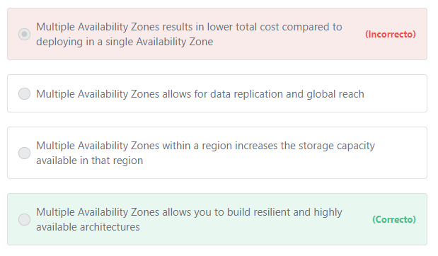Final del formulario

Principio del formulario

**Explicación**

       Resilience is the ability of an architecture to continue providing the same quality of service even if some of its resources become inaccessible. Deploying your resources across multiple Availability Zones offer you the ability to operate production applications and databases that are more resilient, highly available, and scalable than would be possible from a single data center.

***The other options are incorrect:***

***"Multiple Availability Zones within a region increases the storage capacity available in that region" is incorrect.*** In AWS, you have virtually unlimited storage capacity regardless of Regions or Availability Zones in a region.

***"Multiple Availability Zones results in lower total cost compared to deploying in a single Availability Zone" is incorrect.***Deploying your resources across multiple availability zones has no cost benefits.

***"Multiple Availability Zones allows for data replication and global reach" is incorrect.***Multiple Availability Zones within a region allows for data replication but not global reach.

**References:**

<https://aws.amazon.com/about-aws/global-infrastructure/>

Final del formulario

Principio del formulario

Pregunta 40:**Incorrecto**

**​ Which AWS Service is used to manage user permissions?**

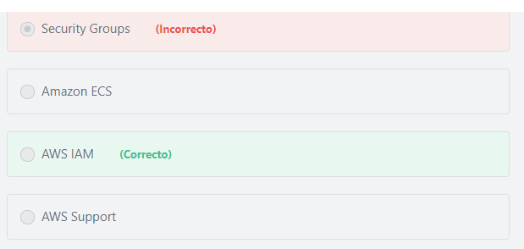Final del formulario

Principio del formulario

**Explicación**

        AWS Identity and Access Management (IAM) enables you to manage access to AWS services and resources securely. Using IAM, you can create and manage AWS users and groups, and use permissions to allow or deny their access to AWS resources.

***The other options are incorrect:***

***"Amazon ECS" is incorrect.*** Amazon ECS is used to run containerized applications on AWS.

***"Security Groups" is incorrect.*** Security Groups is not an AWS service. Security Groups is a networking feature that allows customers to control instance traffic.

***"AWS Support" is incorrect.***AWS Support is not an AWS service. The AWS Support team cannot modify user permissions on customer’s behalf. It is the responsibility of the customer to manage all access permissions.

**References:**

<https://aws.amazon.com/iam/>

Final del formulario

Principio del formulario

Pregunta 41:**Incorrecto**

**Which statement best describes AWS?**

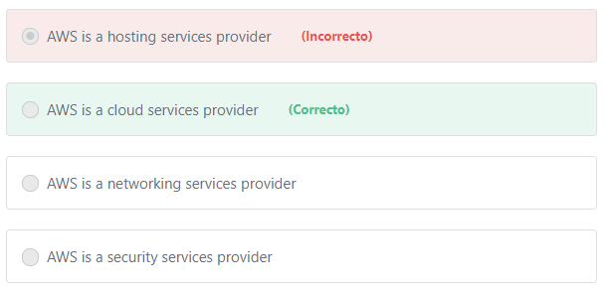Final del formulario

Principio del formulario

**Explicación**

Amazon Web Services offers reliable, scalable, and inexpensive cloud computing services.

***The other options are incorrect:***

          AWS is not just for hosting, security or networking. Amazon Web Services offers a broad set of global cloud-based products including compute, storage, databases, analytics, networking, mobile, developer tools, management tools, IoT, security and enterprise applications. These services help organizations move faster, lower IT costs, and scale. AWS is trusted by the largest enterprises and the hottest start-ups to power a wide variety of workloads including: web and mobile applications, game development, data processing and warehousing, storage, archive, and many others.

**References:**

<https://aws.amazon.com/products/>

Final del formulario

Principio del formulario

Pregunta 42:**Correcto**

**A company has hundreds of VPCs in multiple AWS Regions worldwide. What service does AWS offer to simplify the connection management among the VPCs?**

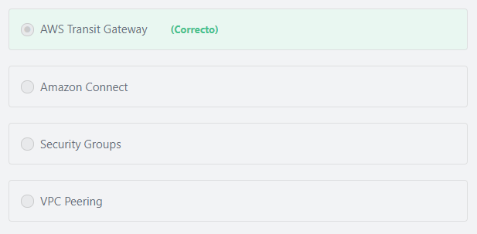Final del formulario

Principio del formulario

**Explicación**

              AWS Transit Gateway is a network transit hub that simplifies how customers interconnect all of their VPCs, across thousands of AWS accounts and into their on-premises networks. Customers can easily and quickly connect into a single centrally-managed gateway, and rapidly growing the size of their network. Transit Gateway acts as a hub that controls how traffic is routed among all the connected networks which act like spokes. This hub and spoke model significantly simplifies management and reduces operational costs because each network only has to connect to the Transit Gateway and not to every other network. Any new VPC is simply connected to the Transit Gateway and is then automatically available to every other network that is connected to the Transit Gateway. This ease of connectivity makes it easy to scale networks as business grow.

***The other options are incorrect:***

***“VPC Peering” is incorrect.*** A VPC peering connection is a networking connection between **two** VPCs that enables customers to route traffic between them using private IPv4 addresses or IPv6 addresses. Instances in either VPC can communicate with each other as if they are within the same network. Using VPC peering to connect hundreds of VPCs is very complex and time consuming because customers need to peer each Amazon VPC to each other manually.

**With**[**AWS Transit Gateway**](https://aws.amazon.com/transit-gateway/)**, each VPC only has to connect to the Transit Gateway and not to every other VPC. Customers simply connect each Amazon VPC to the AWS Transit Gateway, and the Gateway will route traffic to and from each VPC.**

***"Amazon*** ***Connect" is incorrect.*** Amazon Connect is a cloud-based contact center service that makes it easy for businesses to deliver customer service at low cost.

***"Security Groups" is incorrect.*** Security Groups are not used to connect Amazon VPCs. Security Groups are an Amazon VPC networking feature that allows customers to control instance traffic.

**References:**

<https://aws.amazon.com/transit-gateway/>

Final del formulario

Principio del formulario

Pregunta 43:**Incorrecto**

**Why would an organization decide to use AWS over an on-premises data center? (Choose two)**

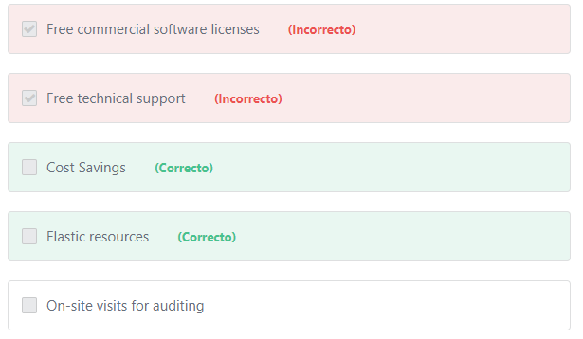Final del formulario

Principio del formulario

**Explicación**

               AWS continues to lower the cost of cloud computing for its customers. AWS recently lowered prices again for compute, storage, caching, and database services for all customers, making everything from web apps to big data on AWS even more cost-effective and widening the TCO gap with traditional infrastructure.

               Elasticity is a system’s ability to monitor user demand and automatically increase and decrease deployed resources accordingly. Elasticity is one of the most important advantages of AWS. The purpose of elasticity is to match the resources allocated with actual amount of resources needed at any given point in time. This ensures that you are only paying for the resources you actually need.

***The other options are incorrect:***

***"Free technical support" is incorrect.*** Technical support is not free in AWS. Technical Support requires subscription to an AWS Support Plan.

***"On-site visits for auditing" is incorrect.*** AWS does not allow on-site visits to its datacenters under any circumstances.

***"Free commercial software licenses" is incorrect.*** Neither AWS nor on-premises datacenters provide free commercial software licenses. However, AWS allows you to pay for these licenses as-you-go. For example, using license included windows instances allows you access to fully compliant Microsoft software licenses bundled with Amazon EC2 or Amazon RDS instances and pay for them as you go with no upfront costs or long-term investments.

**References:**

<https://docs.aws.amazon.com/aws-technical-content/latest/aws-overview/six-advantages-of-cloud-computing.html>

Final del formulario

Principio del formulario

Pregunta 44:**Correcto**

**​ What is the benefit of using an API to access AWS Services?**

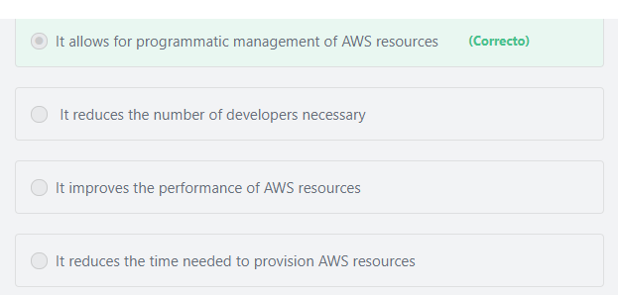Final del formulario

Principio del formulario

**Explicación**

             The AWS Application Programming Interface (API) allows customers to work with various AWS services programmatically.

***The other options are incorrect:***

***"It improves the performance of AWS resources" is incorrect.***There is no difference in performance when you provision resources using the console or using the AWS API. In fact, if you access AWS through the AWS Management Console or through the command line tools, you are actually using tools that make calls to the AWS API.

***"It reduces the time needed to provision AWS resources" is incorrect.***Since AWS Console and AWS CLI both provision resources by making AWS API calls, then there will be no difference in the time needed to provision these resources using either of them.

***"***​***It reduces the number of developers necessary" is incorrect.*** Depending on the use case, using the AWS API may actually require more developers to manage AWS resources programmatically.

**References:**

<https://docs.aws.amazon.com/AWSEC2/latest/APIReference/making-api-requests.html>

Final del formulario

Principio del formulario

Pregunta 45:**Incorrecto**

**Which AWS Service provides the current status of all AWS Services in all AWS Regions?**

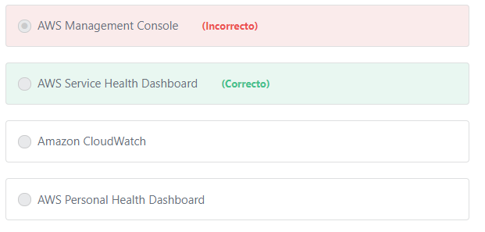Final del formulario

Principio del formulario

**Explicación**

        AWS uses the Service Health Dashboard to publish most up-to-the-minute information on AWS service availability. You can get information about the current status and availability of any AWS service any time using the AWS Service Health Dashboard that is available at this link: https://status.aws.amazon.com/

**The other options are incorrect.**

***"AWS Personal Health Dashboard" is incorrect.***While the Service Health Dashboard displays the general status of AWS services, Personal Health Dashboard gives you a personalized view of the status of the AWS services that power your applications (i.e. not all services), enabling you to quickly see when AWS is experiencing issues that may impact you. For example, in the event of a lost EBS volume associated with one of your EC2 instances, you would gain quick visibility into the status of the specific service you are using, helping save precious time troubleshooting to determine the root cause.

***"Amazon CloudWatch" is incorrect.***You can use Amazon CloudWatch to gain system-wide visibility into resource utilization, application performance, and operational health. You can use these insights to react and keep your application running smoothly.

***"AWS Management Console" is incorrect.***AWS Management Console allows you to access and manage Amazon Web Services through a simple and intuitive web-based user interface.

**References:**  
<https://status.aws.amazon.com/>

Final del formulario

Principio del formulario

Pregunta 46:**Incorrecto**

**​ Which AWS Service creates a virtual network in AWS?**

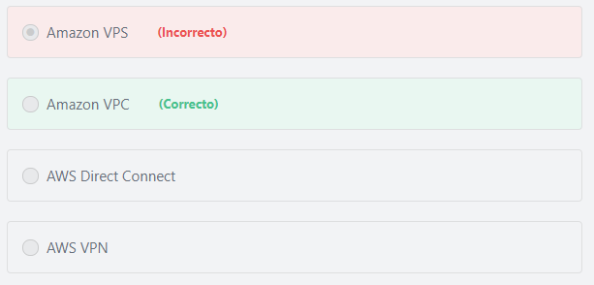Final del formulario

Principio del formulario

**Explicación**

         Amazon Virtual Private Cloud (Amazon VPC) is the service that allows a customer to create a virtual network for their resources in an isolated section of the AWS cloud.

***The other options are incorrect:***

***AWS VPN is incorrect.***Amazon Virtual Private Network (AWS VPN) allows you to establish a secure and private tunnel from your network or device to the AWS global network.

***AWS Direct Connect is incorrect.***AWS Direct Connect allows you to establish a dedicated network connection from your premises to AWS.

***Amazon VPS is incorrect.***A virtual private server (VPS) is a Lightsail instance that lives in the AWS Cloud. You can use your Lightsail instances to store data, run code, and build web-based applications or websites.

**References:**

<https://aws.amazon.com/vpc/>

Final del formulario

Principio del formulario

Pregunta 47:**Incorrecto**

**As part of the AWS Migration Acceleration Program (MAP), what does AWS provide to accelerate Enterprise adoption of AWS? (Choose TWO)**

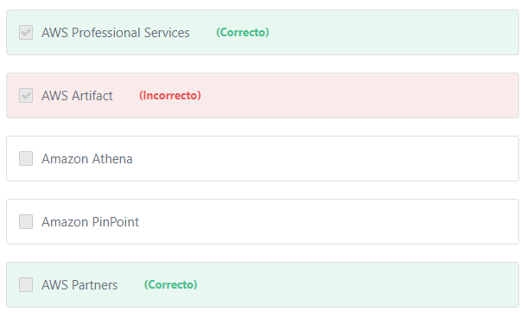Final del formulario

Principio del formulario

**Explicación**

              AWS has helped thousands of organizations, including enterprises such as GE, the Coca-Cola Company, BP, Enel, Samsung, NewsCorp, and Twenty-First Century Fox, migrate to the cloud and free-up resources by lowering IT costs while improving productivity, operational resiliency, and business agility. The AWS Migration Acceleration Program (MAP) is designed to help enterprises that are committed to a migration journey achieve a range of these business benefits by migrating existing workloads to Amazon Web Services. MAP has been created to provide consulting support, training and services credits to reduce the risk of migrating to the cloud, build a strong operational foundation and help offset the initial cost of migrations. It includes a migration methodology for executing legacy migrations in a methodical way as well as robust set of tools to automate and accelerate common migration scenarios.

             By migrating to AWS, enterprises will be able to focus on business innovation instead of dedicating time and attention to maintaining their existing systems and technical debt. Sacrifices and painful trade-offs no longer have to be made to get something to market quickly. Instead, enterprises can focus on differentiating their business in the marketplace and taking advantage of new capabilities. By building the foundation to operate mission critical workloads on AWS, you will build capabilities that can be leveraged across a variety of projects. AWS have a number of resources to support and sustain your migration efforts including an experienced partner ecosystem to execute migrations, AWS Professional Services team to provide best practices and prescriptive advice and a training program to help IT professionals understand and carry out migrations successfully.

***The other options are incorrect:***

***Amazon Athena is incorrect.***Amazon Athena is an interactive query service that makes it easy to analyze data in Amazon S3 using standard SQL.

***Amazon PinPoint is incorrect.*** Amazon PinPoint is used to engage your customers by sending them targeted and transactional email, SMS, push notifications, and voice messages.

***AWS Artifact is incorrect.***AWS Artifact is a no cost, self-service portal for on-demand access to AWS’ compliance reports.

**References:**

<https://aws.amazon.com/migration-acceleration-program/>

Final del formulario

Principio del formulario

Pregunta 48:**Incorrecto**

**​ Which design principles relate to performance efficiency in AWS? (Choose TWO)**

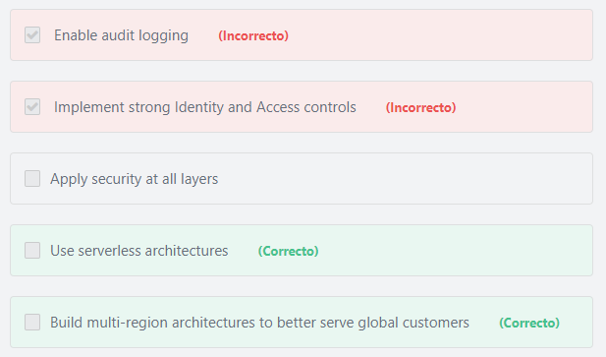Final del formulario

Principio del formulario

**Explicación**

              There are five design principles for performance efficiency in the cloud:

1- Democratize advanced technologies: Technologies that are difficult to implement can become easier to consume by pushing that knowledge and complexity into the cloud vendor's domain. Rather than having your IT team learns how to host and run a new technology, they can simply consume it as a service. For example, NoSQL databases, media transcoding, and machine learning are all technologies that require expertise that is not evenly dispersed across the technical community. In the cloud, these technologies become services that your team can consume while focusing on product development rather than resource provisioning and management.

2- Go global in minutes: Easily deploy your system in multiple Regions around the world with just a few clicks. This allows you to provide lower latency and a better experience for your customers at minimal cost.

3- Use serverless architectures: In the cloud, serverless architectures remove the need for you to run and maintain servers to carry out traditional compute activities. For example, storage services can act as static websites, removing the need for web servers, and event services can host your code for you. This not only removes the operational burden of managing these servers, but also can lower transactional costs because these managed services operate at cloud scale.

4- Experiment more often: With virtual and automatable resources, you can quickly carry out comparative testing using different types of instances, storage, or configurations.

5- Mechanical sympathy: Use the technology approach that aligns best to what you are trying to achieve. For example, consider data access patterns when selecting database or storage approaches.

***Other options presented are related to security not performance.***

**References:**

<https://d1.awsstatic.com/whitepapers/architecture/AWS_Well-Architected_Framework.pdf>

Final del formulario

Principio del formulario

Pregunta 49:**Incorrecto**

**Which of the following are factors in determining the appropriate database technology to use for a specific workload? (Choose two)**

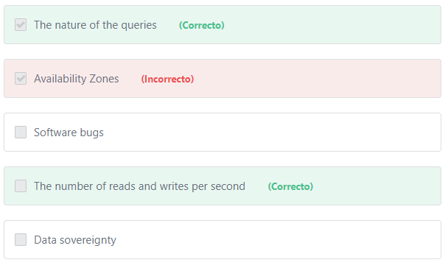Final del formulario

Principio del formulario

**Explicación**

             The following questions can help you take decisions on which solutions to include in your architecture:

- Is this a read-heavy, write-heavy, or balanced workload? How many reads and writes per second are you going to need? How will those values change if the number of users increases?

- How much data will you need to store and for how long? How quickly do you foresee this will grow? Is there an upper limit in the foreseeable future? What is the size of each object (average, min, max)? How are these objects going to be accessed?

- What are the requirements in terms of durability of data? Is this data store going to be your “source of truth”?

- What are your latency requirements? How many concurrent users do you need to support?

- What is your data model and how are you going to query the data? Are your queries relational in nature (e.g.,JOINs between multiple tables)? Could you denormalize your schema to create flatter data structures that are easier to scale?

- What kind of functionality do you require? Do you need strong integrity controls or are you looking for more flexibility (e.g.,schema-less data stores)? Do you require sophisticated reporting or search capabilities? Are your developers more familiar with relational databases than NoSQL?

***The other options are incorrect:***

***"Data sovereignty" is incorrect.***Data sovereignty is the concept that information which has been converted and stored in binary digital form is subject to the laws of the country in which it is located. Data sovereignty is a factor you should consider when choosing your AWS region NOT the database.

***"Software bugs" is incorrect.*** A software bug is an error, flaw, failure, or fault in a system that causes it to produce an incorrect or unexpected result, or to behave in unintended ways. Most bugs are due to human errors made in source code or software design, so if software has bugs, you have to search for a fix. Database technologies cannot help you with application bugs, as they provide services related only to databases.

***"Availability Zones" is incorrect.***Availability zones in a region are all relatively the same. There is no reason to prefer any Availability Zone in which to run a database.

**References:**

<https://aws.amazon.com/products/databases/>

Final del formulario

Principio del formulario

Pregunta 50:**Incorrecto**

**Which of the following can be used to protect data at rest on Amazon S3? (Choose two)**

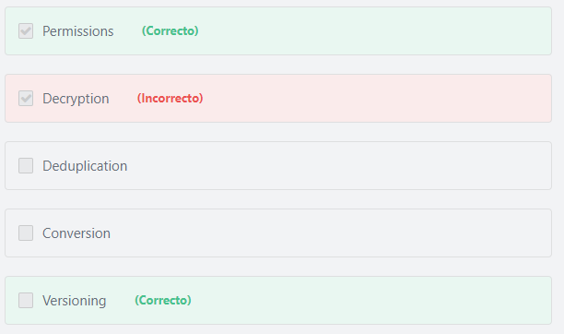Final del formulario

Principio del formulario

**Explicación**

           Amazon S3 provides a number of security features for the protection of data at rest, which you can use or not depending on your threat profile:

1- Permissions: Use bucket-level or object-level permissions alongside IAM policies to protect resources from unauthorized access and to prevent information disclosure, data integrity compromise or deletion.

2- Versioning: Amazon S3 supports object versions. Versioning is disabled by default. Enable versioning to store a new version for every modified or deleted object from which you can restore compromised objects if necessary.

3- Replication: Amazon S3 replicates each object across all Availability Zones within the respective region. Replication can provide data and service availability in the case of system failure, but provides no protection against accidental deletion or data integrity compromise – it replicates changes across all Availability Zones where it stores copies.

4- Backup: You can use application-level technologies to manually back up data stored in Amazon S3 to other AWS regions or to on-premises backup systems.

5- Encryption – server side: Amazon S3 supports server-side encryption of user data. Server-side encryption is transparent to the end user. AWS generates a unique encryption key for each object, and then encrypts the object using AES-256.

6- Encryption – client side: With client-side encryption you create and manage your own encryption keys. Keys you create are not exported to AWS in clear text. Your applications encrypt data before submitting it to Amazon S3, and decrypt data after receiving it from Amazon S3. Data is stored in an encrypted form, with keys and algorithms only known to you.

**Additional information: (IMPORTANT)**

           AWS also provides a fully managed security service called AWS Macie to help protect your sensitive data in Amazon S3. Amazon Macie uses machine learning to automatically discover, classify, and protect sensitive data in Amazon S3. Amazon Macie recognizes sensitive data such as personally identifiable information (PII) or intellectual property, and provides you with dashboards and alerts that give visibility into how this data is being accessed or moved. The fully managed service continuously monitors data access activity for anomalies, and generates detailed alerts when it detects risk of unauthorized access or inadvertent data leaks. Today, Amazon Macie is available to protect data stored in Amazon S3, with support for additional AWS data stores coming later this year.

***The other options are incorrect:***

***"Deduplication" is incorrect.*** Deduplication is the process of removing duplicate data, and will do nothing to prevent data loss of data at rest.

***"Conversion" is incorrect.*** Conversion is the process of transforming data from one format to another.

***"Decryption" is incorrect.*** Decryption is the process of transforming data that has been rendered unreadable through encryption back to its unencrypted form.

**References:**

<https://d1.awsstatic.com/whitepapers/Security/AWS_Security_Best_Practices.pdf>

Final del formulario

Principio del formulario

Pregunta 51:**Incorrecto**

**Which of the below are responsibilities of the customer when using Amazon EC2? (Choose TWO)**

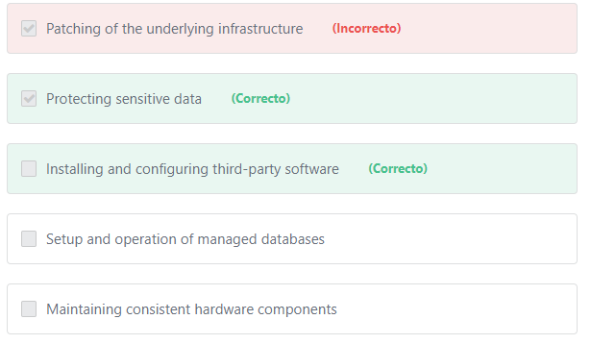Final del formulario

Principio del formulario

**Explicación**

               Amazon EC2 requires the customer to perform all of the necessary security configuration and management tasks. When customers deploy Amazon EC2 instances, they are responsible for management of  custom Amazon Machine Images, management of the guest operating systems (including updates and security patches), securing application access and data, installing and configuring third-party applications or utilities, and the configuration of the AWS-provided firewall (called a security group) on each instance.

***The other options are incorrect:***

***"Patching of the underlying infrastructure" is incorrect.***AWS is responsible for patching the underlying infrastructure. The customer is responsible for patching the operating system and any software or application run on EC2.

***"Setup and operation of managed databases" is incorrect.***

AWS customers have two options to host their databases on AWS:

1- Using a managed database:

AWS Customers can use managed databases such as Amazon RDS and Amazon DynamoDB to host their databases. In this case, **AWS is responsible** for performing all database management tasks such as hardware provisioning, patching, setup, configuration, backups, or recovery.

2- Installing a database software on Amazon EC2:

Instead of using a managed database, AWS customers can install any database software they want on Amazon EC2 and host their databases. In this case, **AWS customers are responsible** for performing all of the necessary configuration and management tasks.

***"Maintaining consistent hardware components" is incorrect.*** AWS is responsible for maintaining consistency of all hardware components.

**References:**

<https://aws.amazon.com/compliance/shared-responsibility-model/>

Final del formulario

Principio del formulario

Pregunta 52:**Incorrecto**

**​ When running a workload in AWS, the customer is NOT responsible for: (Select two)**

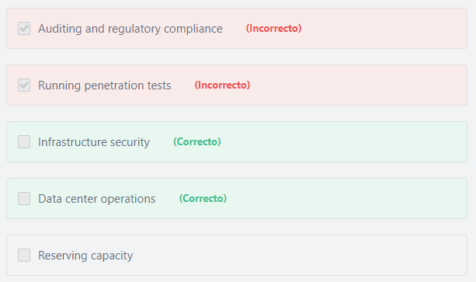Final del formulario

Principio del formulario

**Explicación**

         AWS is responsible for the infrastructure security and all data center operations such as racking, stacking, and powering servers, so customers can focus on revenue generating activities rather than on IT infrastructure.

***The other options are incorrect:***

***"Reserving capacity" is incorrect.***Amazon does not perform reservations for a customer; capacity reservation is a customer action.

***"Running penetration tests" is incorrect.***Penetration testing is the practice of testing a network or web application to find security vulnerabilities that an attacker could exploit. Penetration testing is the responsibility of the customer.

***"Auditing and regulatory compliance" is incorrect.***There are many services on AWS to use for auditing and compliance such as AWS CloudTrail, AWS Config  and Amazon Inspector. However, these services must be configured by the customer, not by AWS.

**References:**

<https://aws.amazon.com/compliance/shared-responsibility-model/>

Final del formulario

Principio del formulario

Pregunta 53:**Incorrecto**

**What is the AWS Compute service that executes code only when triggered by events?**

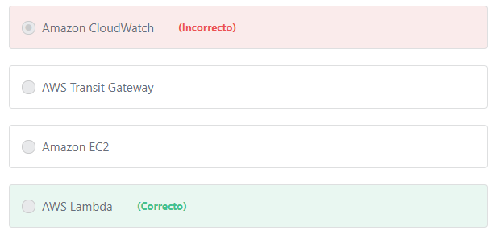Final del formulario

Principio del formulario

**Explicación**

        AWS Lambda is a serverless compute service that runs code in response to events. For example, you can create a Lambda function that creates thumbnail images when users upload images to Amazon S3. The Lambda event, in this case, will be the user’s uploads. Once a user uploads an image to Amazon S3, AWS Lambda will automatically run the application and creates a thumbnail for that image.

***The other options are incorrect:***

***AWS Transit Gateway is incorrect.*** AWS Transit Gateway is a network transit hub that customers can use to interconnect their virtual private clouds (VPCs) and their on-premises networks. AWS transit gateway simplifies how customers interconnect all of their VPCs, across thousands of AWS accounts and into their on-premises networks.

***"Amazon EC2" is incorrect.***After provisioning an EC2 instance, it continues to run all the time until being stopped or terminated. But with Lambda, the application code will run only when triggered.

***"Amazon CloudWatch" is incorrect.***Amazon CloudWatch is a monitoring service, not a compute service.

**References:**

<https://aws.amazon.com/lambda/>

Final del formulario

Principio del formulario

Pregunta 54:**Incorrecto**

**What is the AWS’ recommendation regarding access keys?**

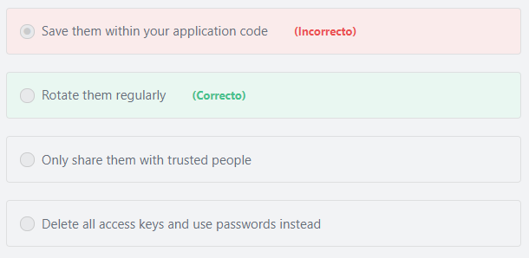Final del formulario

Principio del formulario

**Explicación**

         AWS recommends that you change your own passwords and access keys regularly, and make sure that all IAM users in your account do as well. That way, if a password or access key is compromised without your knowledge, you limit how long the credentials can be used to access your resources.

***The other options are incorrect:***

***"Save them within your application code" is incorrect.*** It is not secure to save any type of credentials within your application code.

***"Only share them with trusted people" is incorrect.***AWS recommends that you do not ever share your root credentials with anyone.

***"Delete all access keys and use passwords instead" is incorrect.*** Usernames and passwords are used to sign in to the AWS management console. They cannot be used to sign programmatic requests to the AWS CLI or AWS API like access keys.

**References:**

<https://docs.aws.amazon.com/IAM/latest/UserGuide/best-practices.html>

Final del formulario

Principio del formulario

Pregunta 55:**Incorrecto**

**A company has a large amount of data to be archived. What is the most cost-effective AWS storage service to use?**

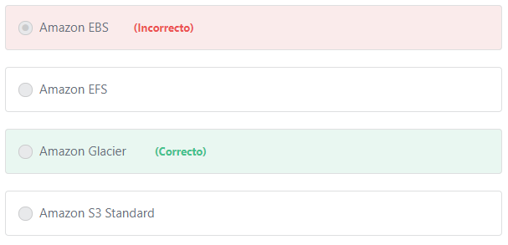Final del formulario

Principio del formulario

**Explicación**

           Amazon Glacier is a secure, durable, and extremely low-cost cloud storage service for data archiving and long-term backup. It is designed to deliver 99.999999999% durability, and provides comprehensive security and compliance capabilities that can help meet even the most stringent regulatory requirements.

***The other options are incorrect:***

***Amazon EFS is incorrect.*** Amazon Elastic File System (Amazon EFS) is not a cost effective solution for data archiving. Amazon EFS is a **file** level storage service that is designed to provide massively parallel shared access to thousands of Amazon EC2 instances, enabling your applications to achieve high levels of aggregate throughput and IOPS with consistently low latencies.

***Amazon S3 Standard is incorrect.***AmazonS3 Standard is not a cost-effective solution for data archiving. Amazon S3 Standard offers high durability, availability, and performance **object** storage for frequently accessed data. S3 Standard use cases include: cloud applications, dynamic websites, content distribution, mobile and gaming applications, and big data analytics.

***Amazon EBS is incorrect.***AmazonEBS is not a cost-effective solution for data archiving. Amazon EBS provides **block** level storage volumes for use with Amazon EC2 and RDS instances.

**References:**

<https://aws.amazon.com/glacier/>

Final del formulario

Principio del formulario

Pregunta 56:**Incorrecto**

**Which AWS Service enables customers to set up an AWS billing alarm to inform them when their spending exceeds a certain threshold?**

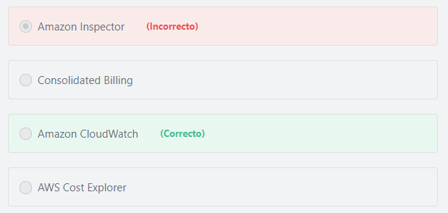Final del formulario

Principio del formulario

**Explicación**

        Amazon CloudWatch is the AWS service that allows you to monitor the usage of your AWS resources. CloudWatch collects metrics, and allows you to create alarms based on those metrics.  You can use CloudWatch to monitor your estimated AWS charges. When you enable the monitoring of estimated charges for your AWS account, the estimated charges are calculated and sent several times daily to CloudWatch as metric data. Billing metric data includes the estimated charges for every service in AWS that you use, in addition to the estimated overall total of your AWS charges. The alarm triggers when your account billing exceeds the threshold you specify.

***The other options are incorrect:***

***AWS Cost Explorer is incorrect.***AWS Cost Explorer is used to view and analyze your costs and usage. You can explore your usage and costs using graphs and the Cost Explorer cost and usage reports.

***Consolidated Billing is incorrect.*** The consolidated billing is a feature in AWS Organizations that enables you to consolidate billing and payment for multiple AWS accounts.

***Amazon Inspector is incorrect.*** Amazon Inspector is an automated security assessment service to help improve the security and compliance of applications deployed on AWS

**References:**

<https://docs.aws.amazon.com/AmazonCloudWatch/latest/monitoring/monitor_estimated_charges_with_cloudwatch.html>

Final del formulario

Principio del formulario

Pregunta 57:**Correcto**

**Which of the following is NOT a characteristic of Amazon Elastic Compute Cloud (Amazon EC2)?**

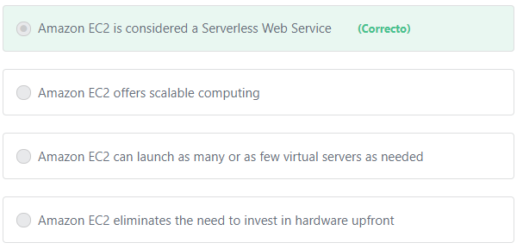Final del formulario

Principio del formulario

**Explicación**

***"Amazon EC2 is considered a Serverless Web Service"***  is not a characteristic of Amazon EC2 and thus is the correct choice. Serverless allows customers to shift more operational responsibilities to AWS. Serverless allows customers to build and run applications and services without thinking about servers. Serverless eliminates infrastructure management tasks such as server or cluster provisioning, patching, operating system maintenance, and capacity provisioning.

          Amazon EC2 is not a serverless service. EC2 instances are virtual servers in the cloud. Amazon Elastic Compute Cloud (Amazon EC2) provides scalable computing capacity in the Amazon Web Services (AWS) cloud. Using Amazon EC2 eliminates your need to invest in hardware upfront, so you can develop and deploy applications faster. You can use Amazon EC2 to launch as many or as few virtual servers as you need, configure security and networking, and manage storage. Amazon EC2 enables you to scale up or down to handle changes in requirements or spikes in popularity, reducing your need to forecast traffic.

**References:**

<http://docs.aws.amazon.com/AWSEC2/latest/UserGuide/concepts.html>

Final del formulario

Principio del formulario

Pregunta 58:**Incorrecto**

**Which of the following allows you to create new RDS instances? (Choose two)**

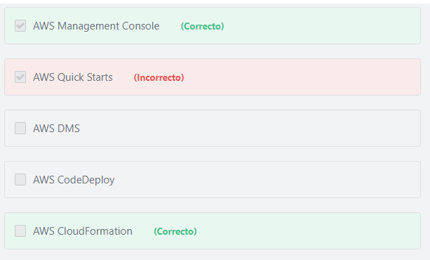Final del formulario

Principio del formulario

**Explicación**

The AWS Management Console lets you create new RDS instances through a web-based user interface.

You can also use AWS CloudFormation to create new RDS instances using the CloudFormation template language.

***The other options are incorrect:***

***AWS DMS is incorrect.***AWS DMS is used to migrate databases to AWS.

***AWS Quick Starts is incorrect.***Quick Starts are built by AWS solutions architects and partners to help you deploy popular technologies on AWS, based on AWS best practices for security and high availability. These accelerators reduce hundreds of manual procedures into just a few steps, so you can build your production environment quickly and start using it immediately.

***AWS CodeDeploy is incorrect.***AWS CodeDeploy is a fully managed deployment service that automates software deployments to a variety of compute services such as Amazon EC2, AWS Fargate, AWS Lambda, and your on-premises servers.

**References:**

<https://docs.aws.amazon.com/awsconsolehelpdocs/index.html>

<https://aws.amazon.com/cloudformation/>

Final del formulario

Principio del formulario

Pregunta 59:**Incorrecto**

**​ What are AWS shared controls?**

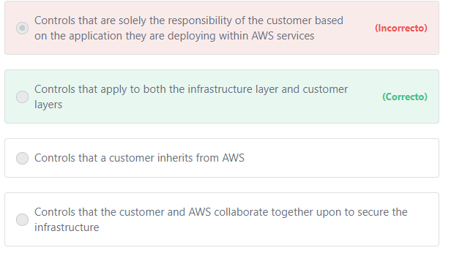Final del formulario

Principio del formulario

**Explicación**

             Shared Controls are controls which apply to both the infrastructure layer and customer layers, but in completely separate contexts or perspectives. In a shared control, AWS provides the requirements for the infrastructure and the customer must provide their own control implementation within their use of AWS services. Examples include:

** Patch Management – AWS is responsible for patching the underlying hosts and fixing flaws within the infrastructure, but customers are responsible for patching their guest OS and applications.

** Configuration Management – AWS maintains the configuration of its infrastructure devices, but a customer is responsible for configuring their own guest operating systems, databases, and applications.

** Awareness & Training - AWS trains AWS employees, but a customer must train their own employees.

***The other options are incorrect:***

***"Controls that are solely the responsibility of the customer based on the application they are deploying within AWS services" is incorrect*** because it refers to “Customer-Specific” controls.

***"Controls that a customer inherits from AWS" is incorrect*** because it refers to “Inherited Controls”.

***"Controls that the customer and AWS collaborate together upon to secure the infrastructure" is incorrect.*** Securing the infrastructure is the responsibility of AWS, not the customer.

**References:**

<https://aws.amazon.com/compliance/shared-responsibility-model/>

Final del formulario

Principio del formulario

Pregunta 60:**Incorrecto**

**A company is planning to migrate a database with high read/write activity to AWS. What is the best storage option to use?**

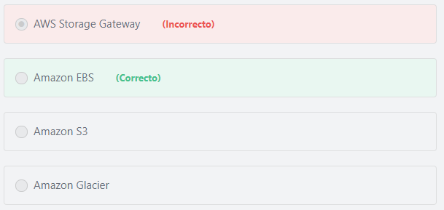Final del formulario

Principio del formulario

**Explicación**

            Databases require high read \ write performance and as such Amazon EBS is the correct answer. Amazon EBS volumes offer consistent and low-latency performance compared to other storage options. You can use EBS volumes as primary storage for data that requires frequent updates, such as the system drive for an instance or storage for a database application.

***The other options are incorrect:***

***Amazon Glacier is incorrect.***Amazon Glacier is a long-term object-level data storage.

***AWS Storage Gateway is incorrect.***AWS Storage Gateway is a hybrid storage service that enables your on-premises applications to seamlessly use AWS cloud storage.

***Amazon S3 is incorrect.***Amazon S3 is an object-level storage, not block-level storage. Object storage is not suited for use in a high read/write scenarios because of performance limitations. In contrast, Amazon EBS is a block-level storage that provides an extremely high performance compared to Amazon S3. Amazon S3 is well suited for storing static assets such as photos and videos, backups, and log files.

**References:**

<https://docs.aws.amazon.com/AWSEC2/latest/UserGuide/AmazonEBS.html>

Final del formulario

Principio del formulario

Pregunta 61:**Incorrecto**

**What is the minimum level of AWS support that provides 24x7 access to technical support engineers via phone and chat?**

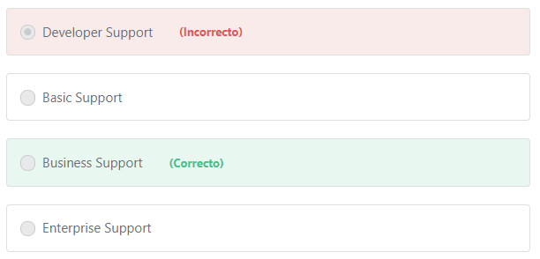Final del formulario

Principio del formulario

**Explicación**

       Each of the Business and Enterprise support plans provide 24x7 access to technical support engineers via phone, email, and chat. The Business Support Plan is less expensive than the Enterprise Support Plan. Therefore, the correct answer is Business.

***The other options are incorrect:***

***"Basic Support" is incorrect.*** The technical support is not available for the Basic support plan.

***"Developer Support" is incorrect.***Developer support plan provides business hours access to technical support associates via email only.

**References:**

<https://aws.amazon.com/premiumsupport/plans/>

Final del formulario

Principio del formulario

Pregunta 62:**Incorrecto**

**Why do many startup companies prefer AWS over traditional on-premises solutions? (Choose TWO)**

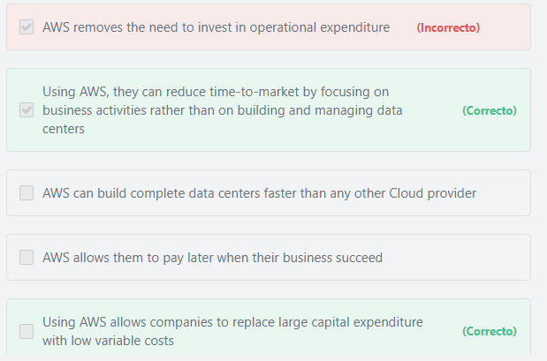Final del formulario

Principio del formulario

**Explicación**

         Instead of building and managing data centers, AWS provides startups, enterprises, and government agencies all the services they need to quickly build their business and grow faster. AWS has significantly more services, and more features within those services, than any other cloud provider – from infrastructure technologies like compute, storage, and databases –to emerging technologies, such as machine learning and artificial intelligence, data lakes and analytics, and Internet of Things. This makes it faster, easier, and more cost effective to build nearly anything they can imagine.

        Capital expenditures (CapEx) are a company's major, long-term expenses. Examples of CAPEX include physical assets such as buildings, equipment, and machinery.

         Instead of having to invest heavily in these Capital expenditures (e.g. physical data centers and servers) before it is known they will be used, companies can pay only when consuming AWS resources, and pay only for how much they consume. In brief, AWS replaces their investments in large capital expenditures (CAPEX) with low variable "pay-as-you-go" costs.

***The other options are incorrect:***

***"AWS can build complete data centers faster than any other Cloud provider" is incorrect.*** AWS does not build out physical data centers for customers, only for itself. AWS is a Cloud Computing provider.

***"AWS removes the need to invest in operational expenditure" is incorrect.*** Operating expenses (OpEx) are a company's day-to-day expenses. Examples of OPEX include employee salaries, rent, utilities, and property taxes. With AWS,Startups can reduce (not remove) their day to day operating expense (OpEx) costs.

***"AWS allows them to pay later when their business succeed" is incorrect.***AWS does not offer a "pay later" option for its customers. AWS provides three payment models: "Pay-as-you-go", "Save when you reserve" and "Pay less by using more".

**References:**

<https://aws.amazon.com/what-is-aws/>

<https://docs.aws.amazon.com/whitepapers/latest/aws-overview/six-advantages-of-cloud-computing.html>

<https://aws.amazon.com/pricing/>

Final del formulario

Principio del formulario

Pregunta 63:**Correcto**

**Both AWS and traditional IT distributors provide a wide range of virtual servers to meet their customers’ requirements. What is the name of these virtual servers in AWS?**

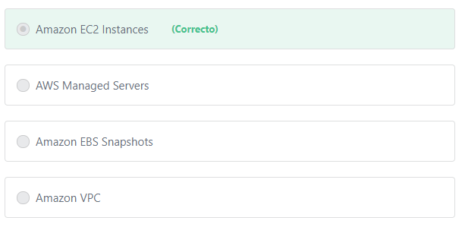Final del formulario

Principio del formulario

**Explicación**

        Amazon Elastic Compute Cloud (Amazon EC2) is a web service that provides secure, resizable compute capacity in the cloud. It is designed to make web-scale cloud computing easier for developers. Amazon EC2’s simple web service interface allows you to obtain and configure capacity with minimal friction. It provides you with complete control of your computing resources and lets you run on Amazon’s proven computing environment. Amazon EC2 reduces the time required to obtain and boot new server instances to minutes, allowing you to quickly scale capacity, both up and down, as your computing requirements change. Amazon EC2 changes the economics of computing by allowing you to pay only for capacity that you actually use. Amazon EC2 provides developers the tools to build failure resilient applications and isolate them from common failure scenarios.

***The other options are incorrect:***

***"Amazon VPC" is incorrect.*** Amazon VPC is a networking service.

***"AWS Managed Servers" is incorrect.***Amazon EC2 instances are not managed by AWS. It is the responsibility of the customer to manage almost everything related to their instances.

***"Amazon EBS Snapshots" is incorrect.*** Amazon EBS Snapshots are copies (backups) of EBS volumes.

**References:**

<https://aws.amazon.com/ec2/>

Final del formulario

Principio del formulario

Pregunta 64:Omitido

**What is the AWS IAM feature that provides an additional layer of security on top of user-name and password authentication?**

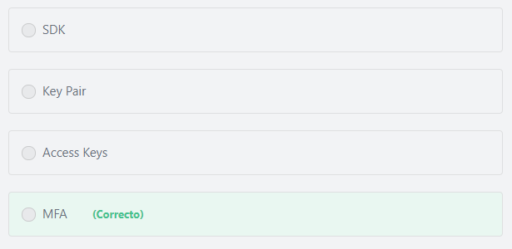Final del formulario

#### Explicación

                AWS Multi-Factor Authentication (MFA) is a simple best practice that adds an extra layer of protection on top of your user name and password. With MFA enabled, when a user signs in to an AWS website, they will be prompted for their user name and password (the first factor—what they know), as well as for an authentication code from their AWS MFA device (the second factor—what they have). Taken together, these multiple factors provide increased security for your AWS account settings and resources.

**The other options are incorrect:**

**"Access Keys" is incorrect.**Access keys are long-term credentials for an IAM user or the AWS account root user. You can use access keys to sign programmatic requests to the AWS CLI or AWS API (directly or using the AWS SDK).

**"Key Pair" is incorrect.**The AWS Key pair cryptography enables you to securely access your Amazon EC2instances using a private key instead of a password.

**"SDK" is incorrect.** AWS SDKs are used to simplify using AWS services in your applications with an API tailored to your programming language or platform. AWS SDKs in AWS include Java SDK, .NET SDK, Node.js SDK and many others.

**References:**

<https://aws.amazon.com/iam/details/mfa/>

Pregunta 65:**Correcto**

**Which of the following is a benefit of running an application in multiple Availability Zones?**

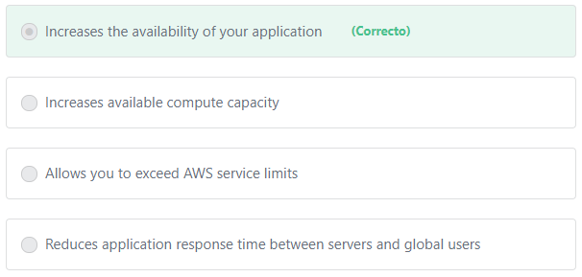

#### Explicación

               Placing instances that run your application in multiple Availability Zones improves the fault tolerance of your application. If one Availability Zone experiences an outage, traffic is routed to another Availability Zone, and this will increase the availability of your application.

**The other options are incorrect:**

**"Increases available compute capacity" is incorrect.** You can provision virtually unlimited compute capacity regardless of the number of Availability Zones.

**"Reduces application response time between servers and global users" is incorrect.**The question didn’t mention whether these Availability Zones exists within a single region or multiple regions. Application response time for global users can only be improved if you deploy to multiple regions around the world.

**"Allows you to exceed AWS service limits" is incorrect.**AWS service limits are region-specific NOT AZ-specific.

**References:**

<https://docs.aws.amazon.com/AWSEC2/latest/UserGuide/using-regions-availability-zones.html>